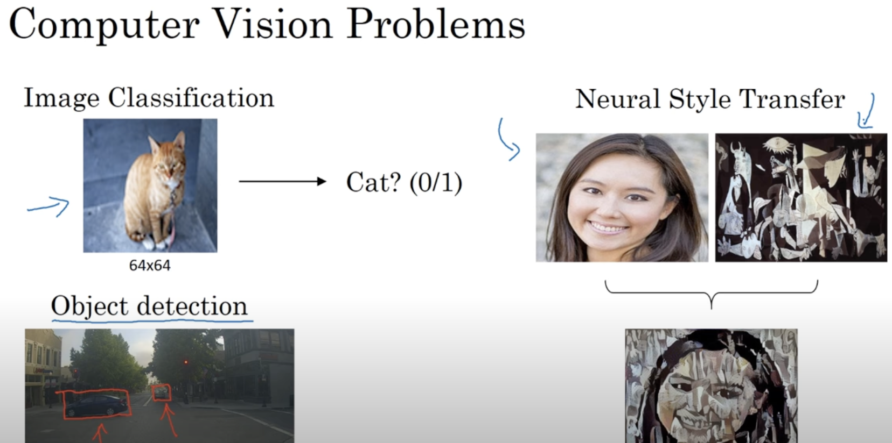

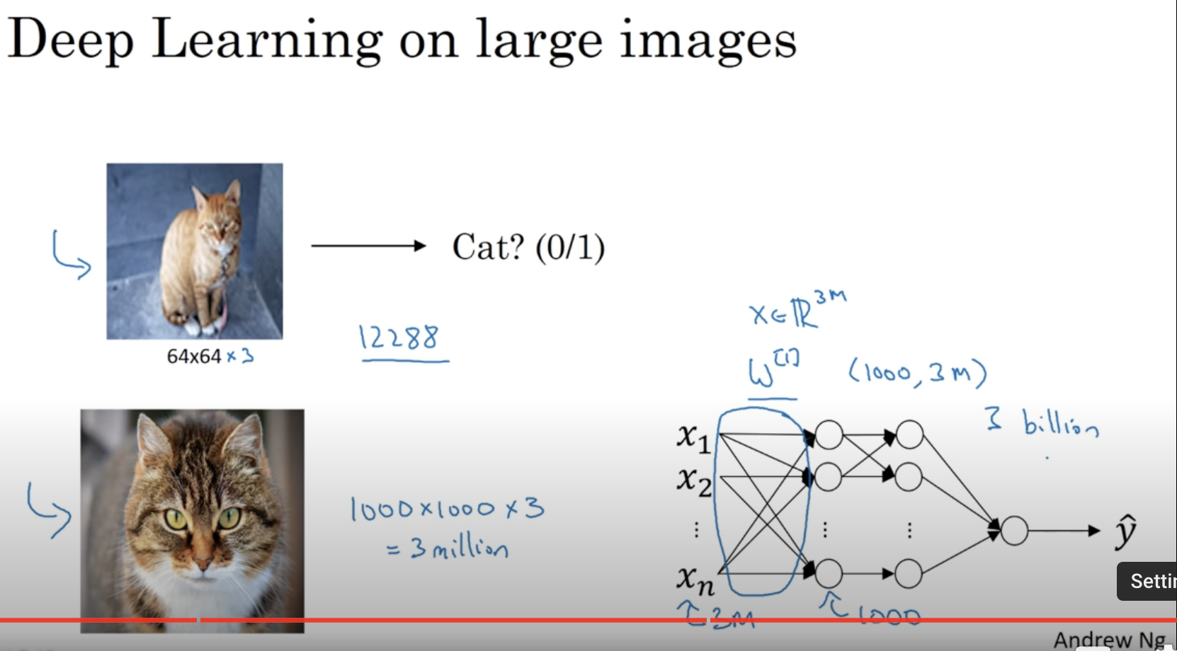

# **Edge Detection Example**

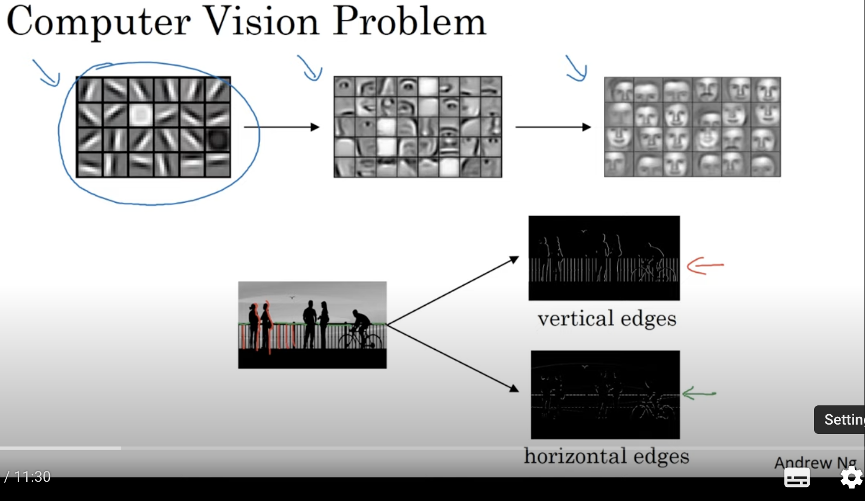

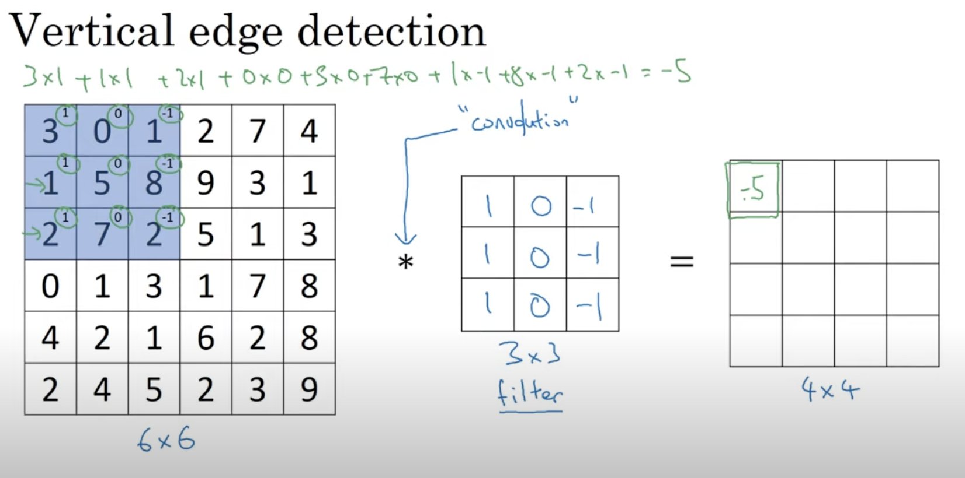

*->convolution

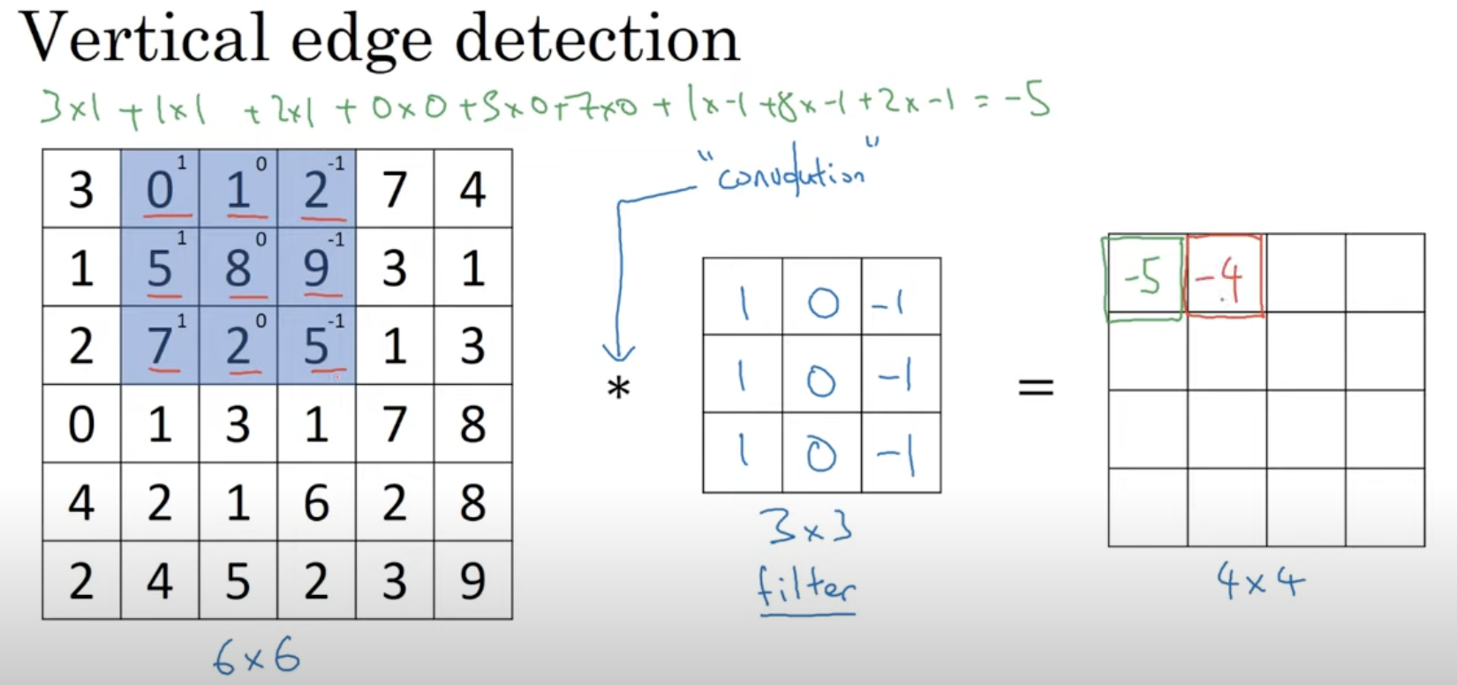

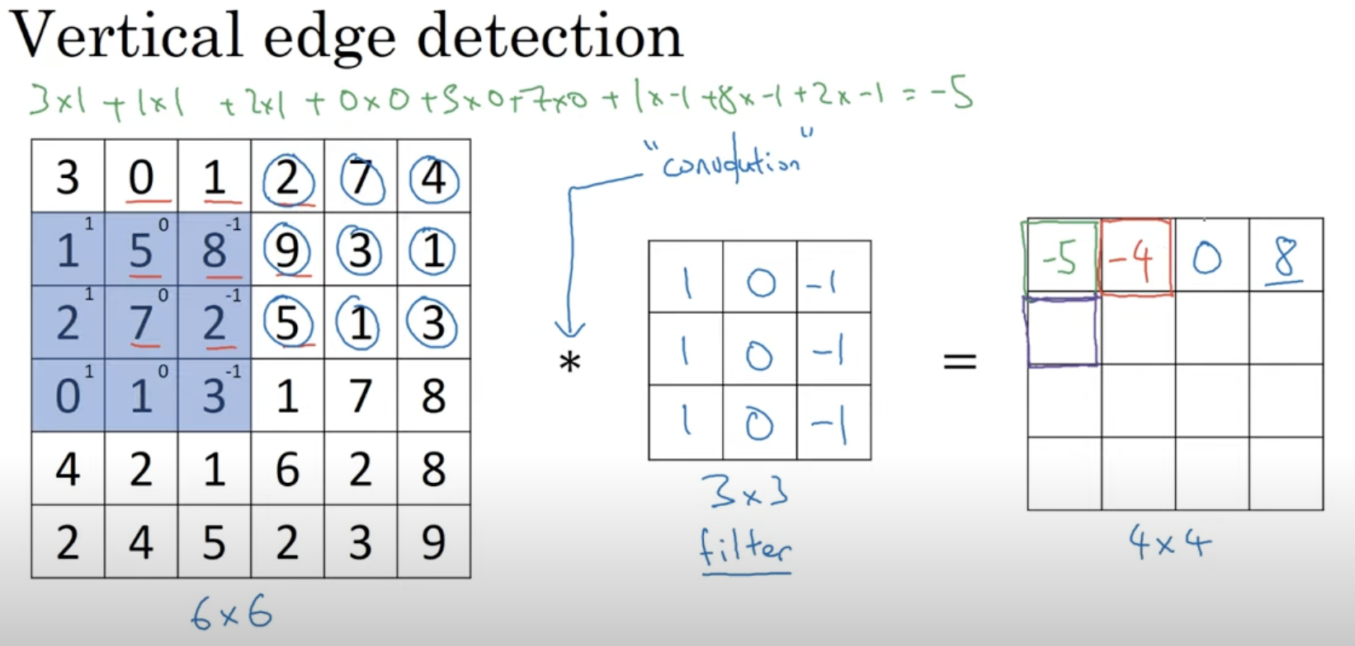

Bright region in the middle 🡪 Strong vertical edge in the original image

Vertical edge is a 3*3 region, since we are using a 3*3 filter where the   
bright pixels on the left , dark pixels on the right

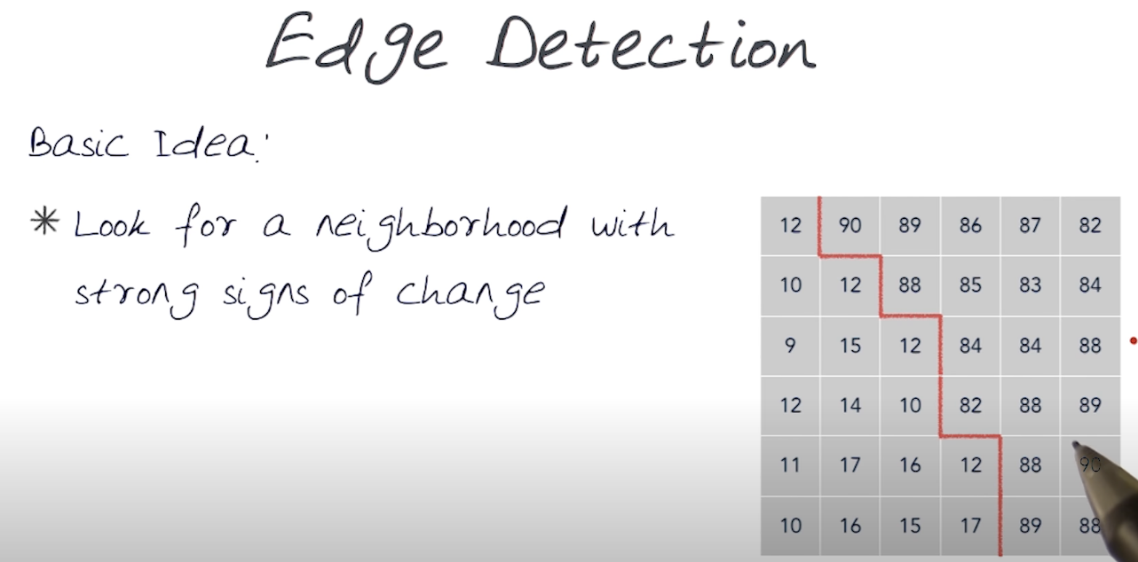

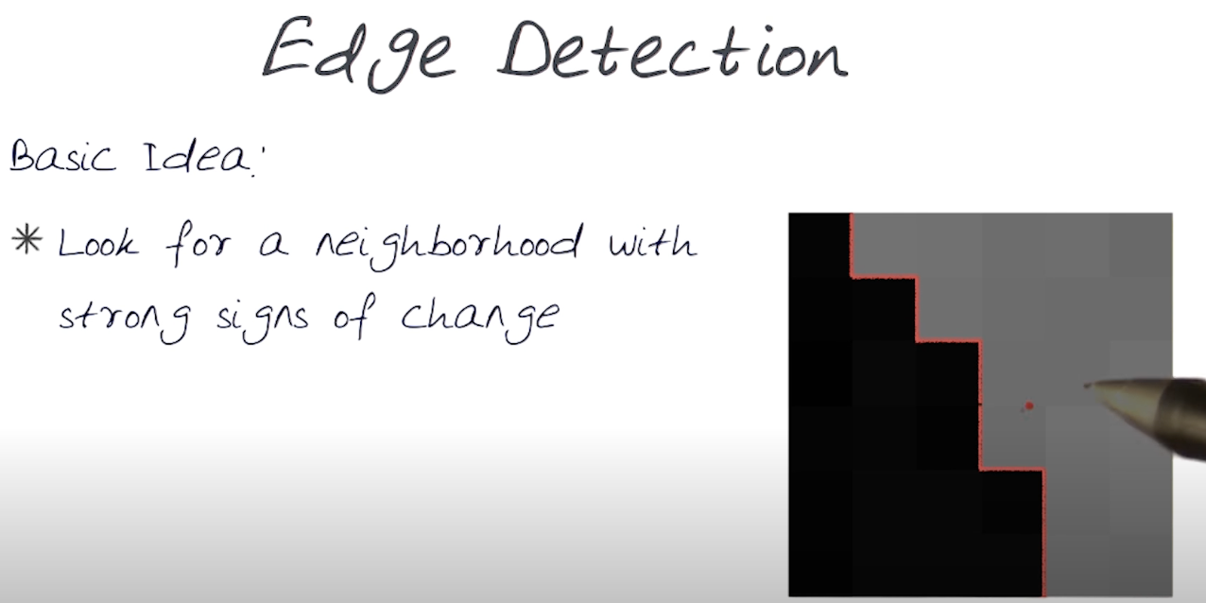

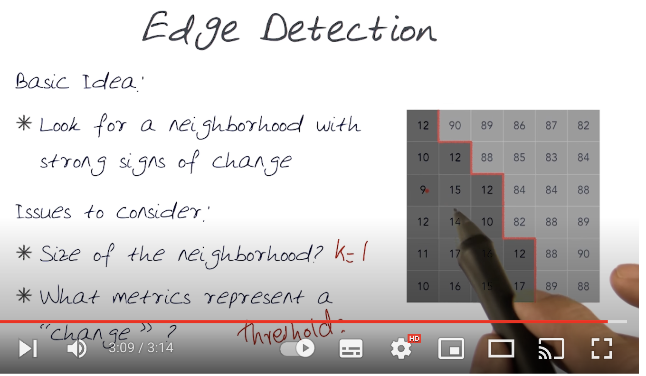

# **More Edge Detection**

Let’s see the effect of light to dark and dark to light

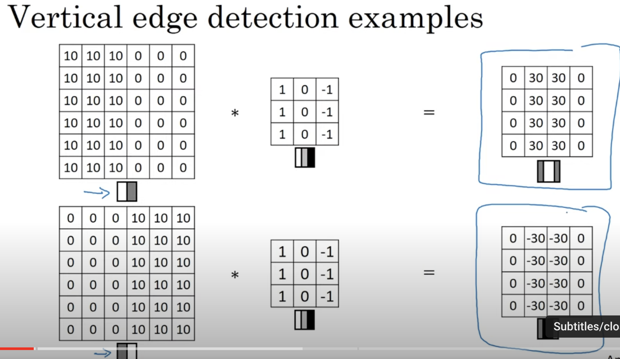

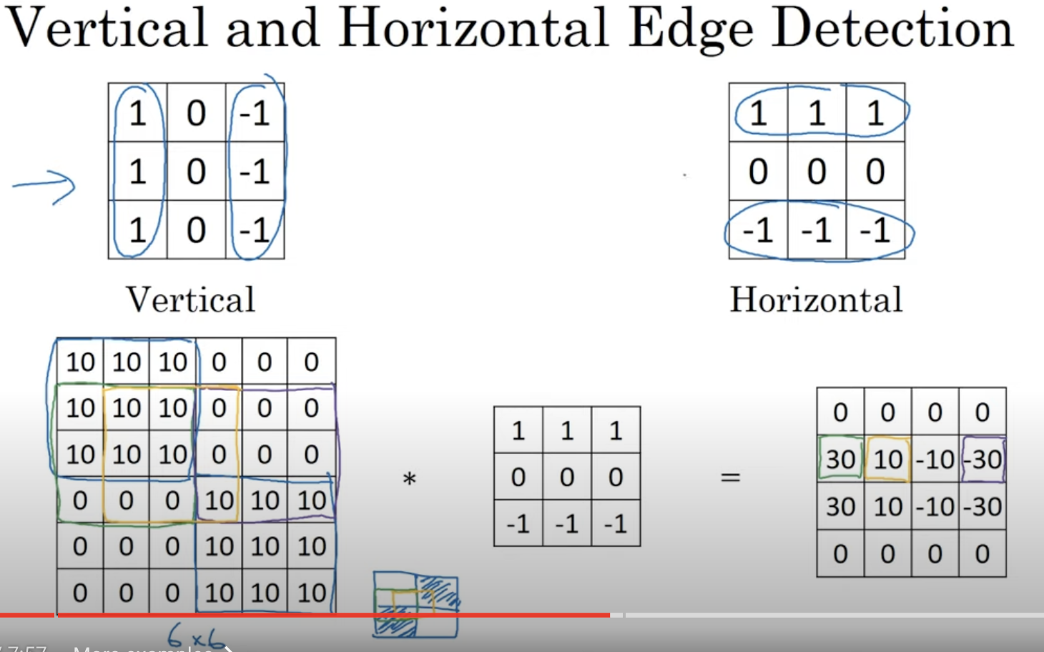

Vertical 🡪 Pictures are relatively bright on left side and relatively dark on right side.  
Horizontal 🡪 Pictures are relatively bright on top side and relatively dark on bottom side.

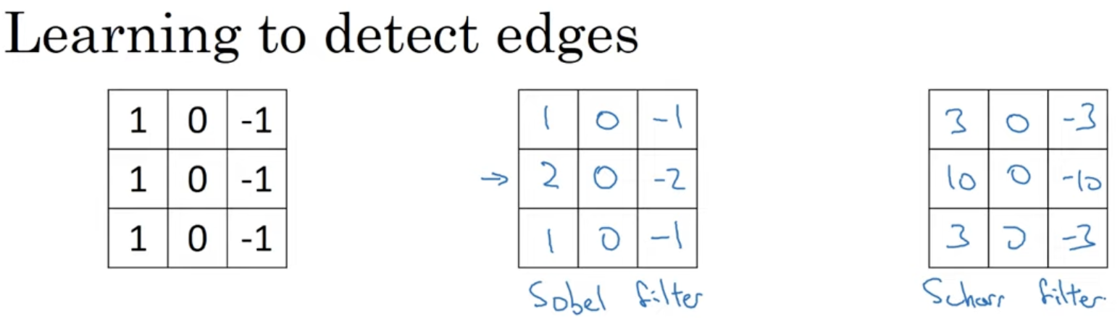

Sobel filter 🡪 gives little bit more weight to the central pixels.

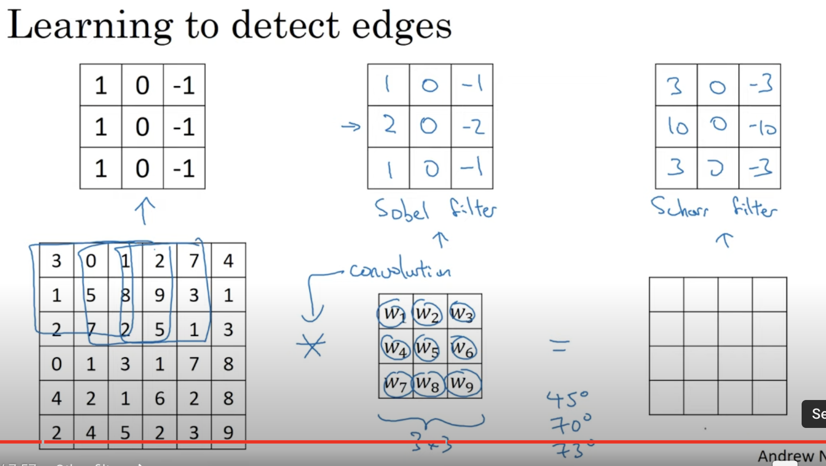

The above are vertical edge detectors, and if we flip 90 degrees, then will get horizontal edge detectors.

If we really want to detect some edges in complicated images, we don’t want to handpick the edges instead we can use a Deep Learning Model to detect these parameters.

Not only vertical and horizontal edges, we can still use some orientations also like 45 degree, 70 degree etc.

Convolution operation 🡪 allows back propagation to learn this 3*3 filter once and to apply it through this entire image

# **Padding**

## **Downside of Convolution**

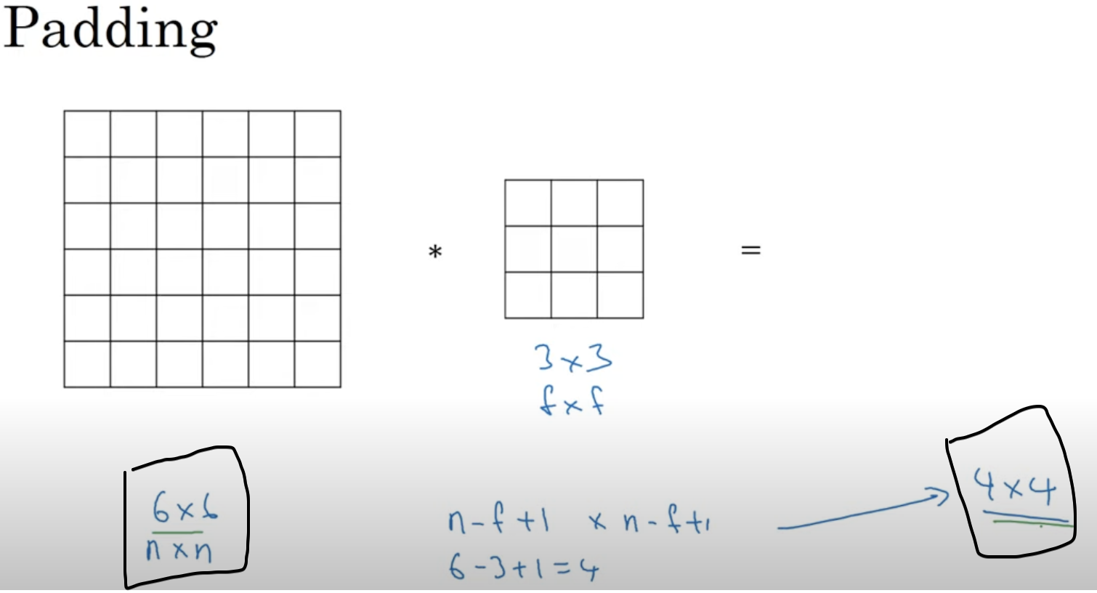

Shrinking Output

1. Every-time, I apply convolution operation the image shrinks (i.e from 6*6 to 4*4)

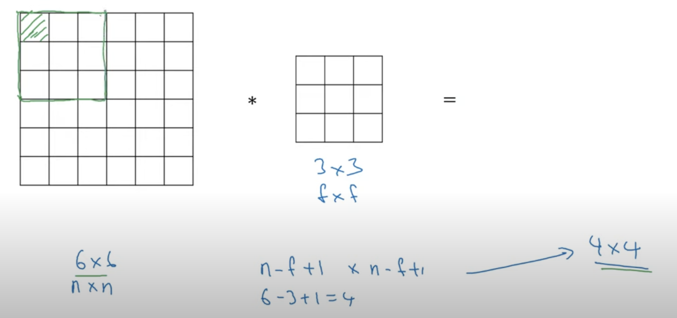

Throw away the info from the edges

1. Pixels on the corners/edges 🡪 used much less in the output,   
   So in this pixel, there is a loss of info.

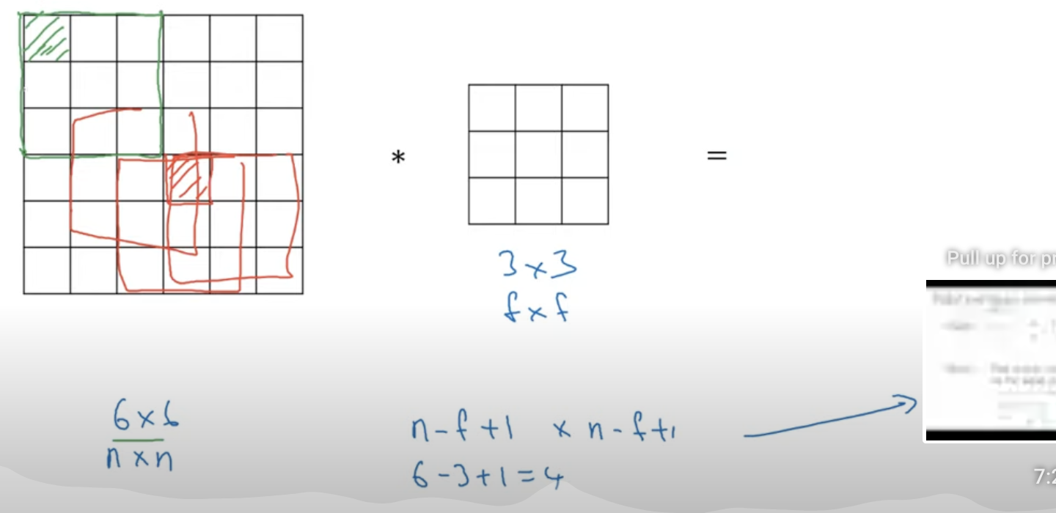  
But these orange pixels are over-lapped many times in all the combinations.  
So this pixel info is not lost.

## **From Geeks**

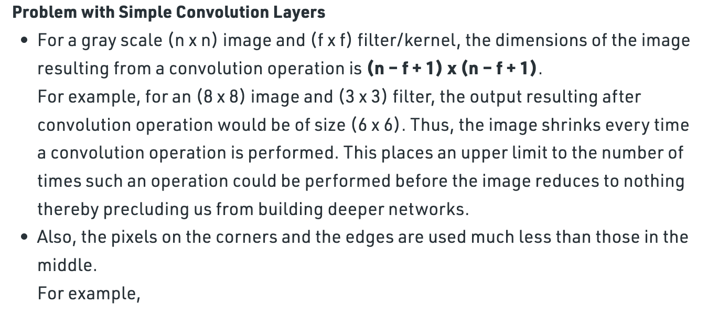  
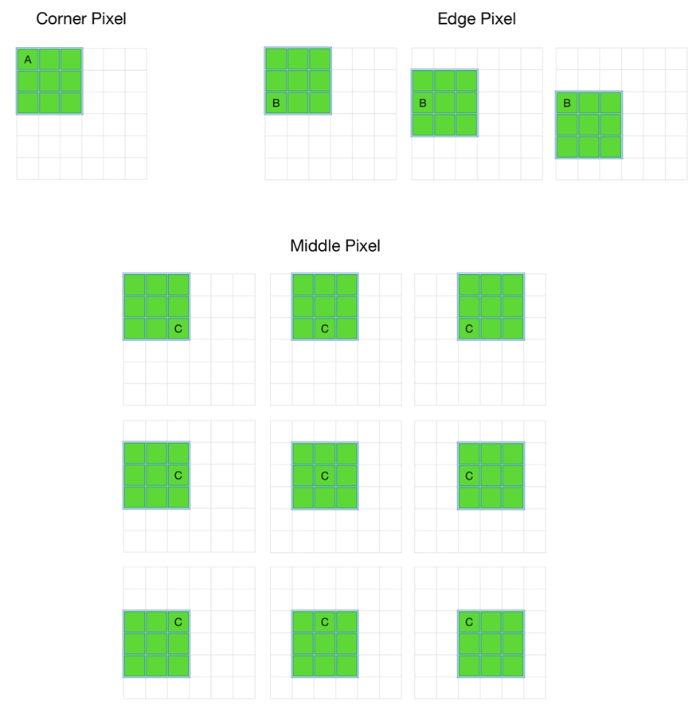

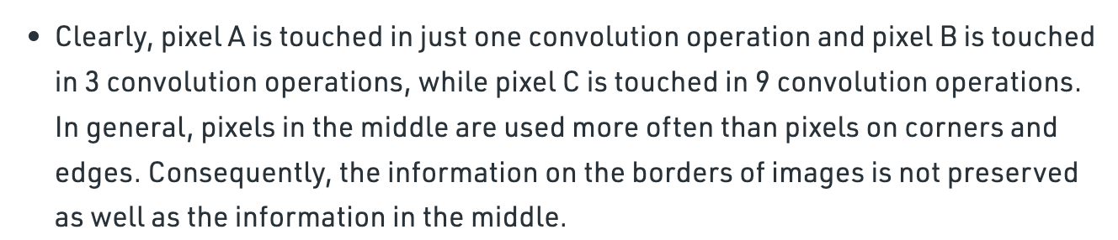

Before applying convolutional operation, apply padding before applying convolutional.  
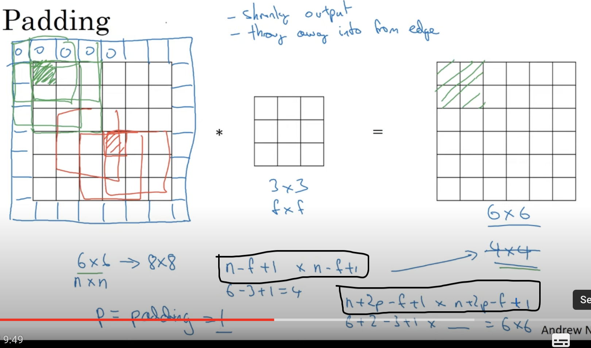  
Here we applied padding p=1  
Now the pixel around the edges are not lost.

Even we can add more padding  
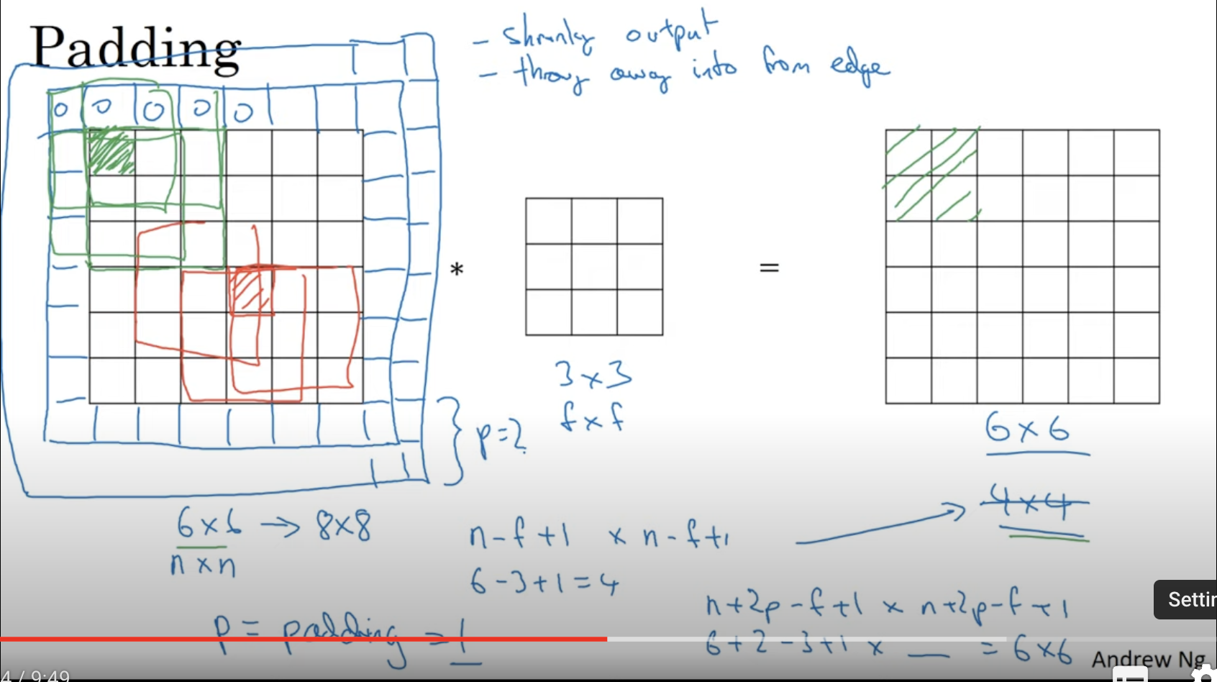

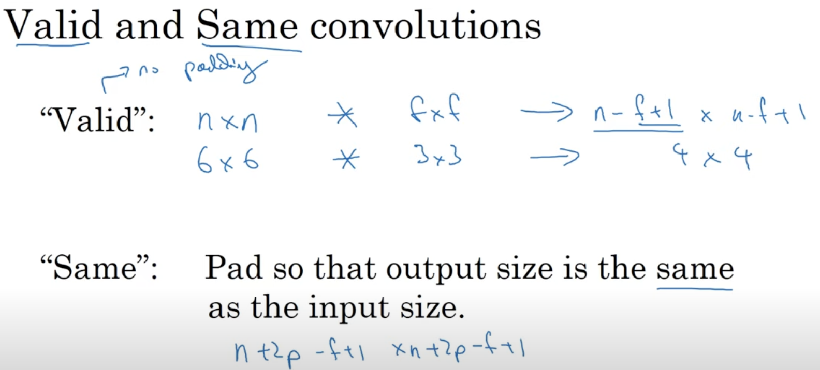

Valid 🡪 No padding (i.e padding = 0)  
Same 🡪 Padding (input size = output size)

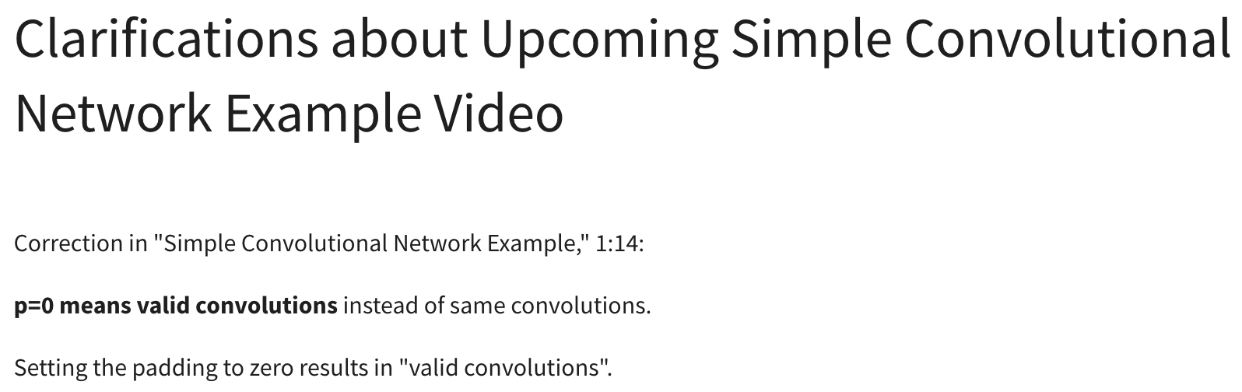

To keep the input size = output size  


So solve this condition **p=(f-1) / 2**

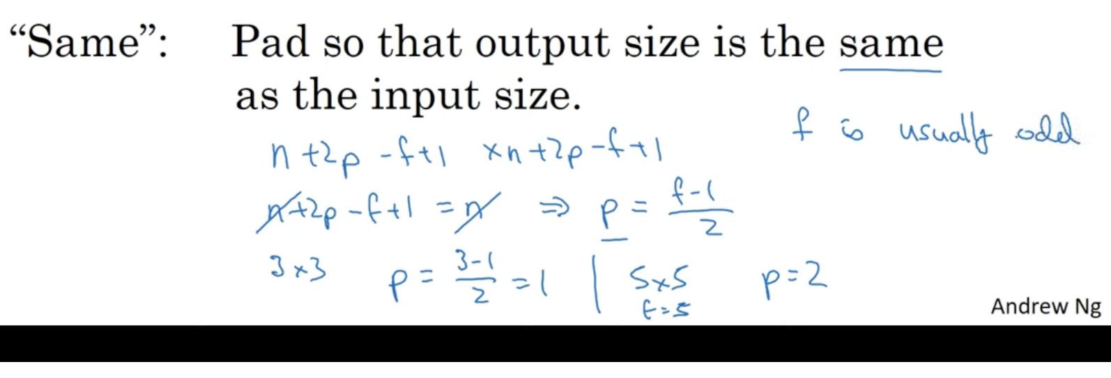Lets take a 3*3 image, p=1  
Lets take a 5*5 image, p=2

**What if when the dimension f is odd ???**

**What if when the dimension f is even ???**

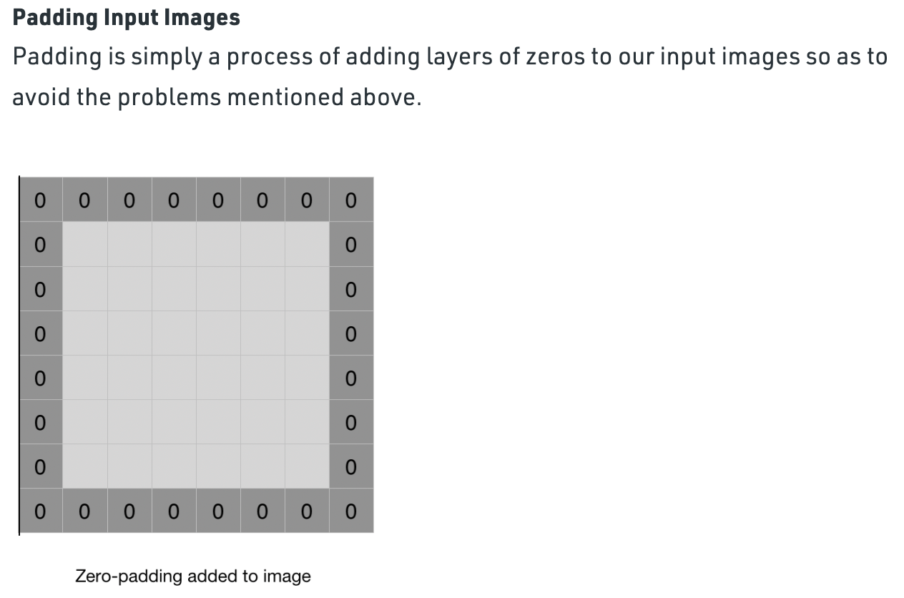

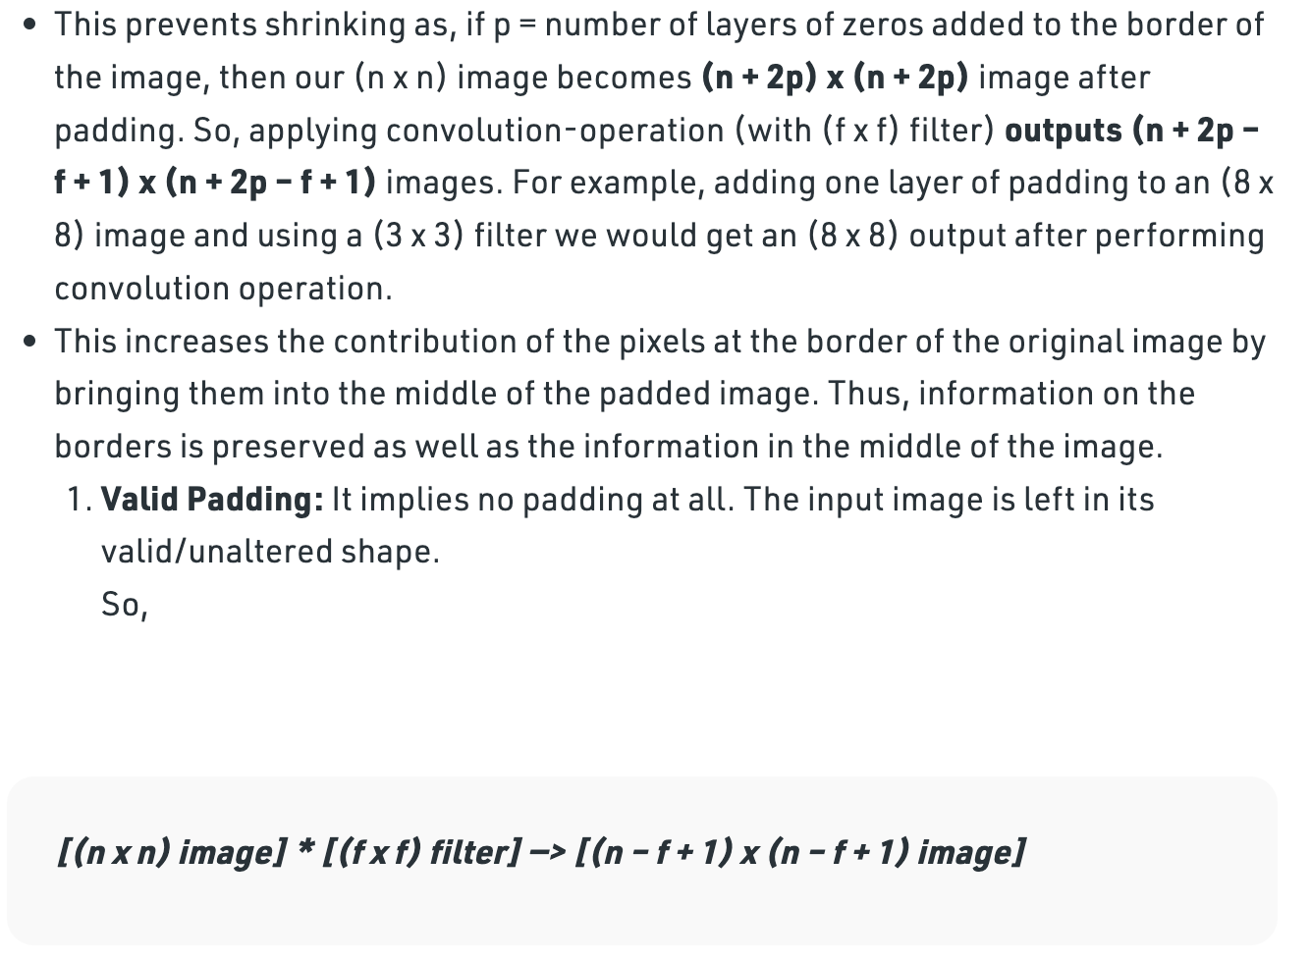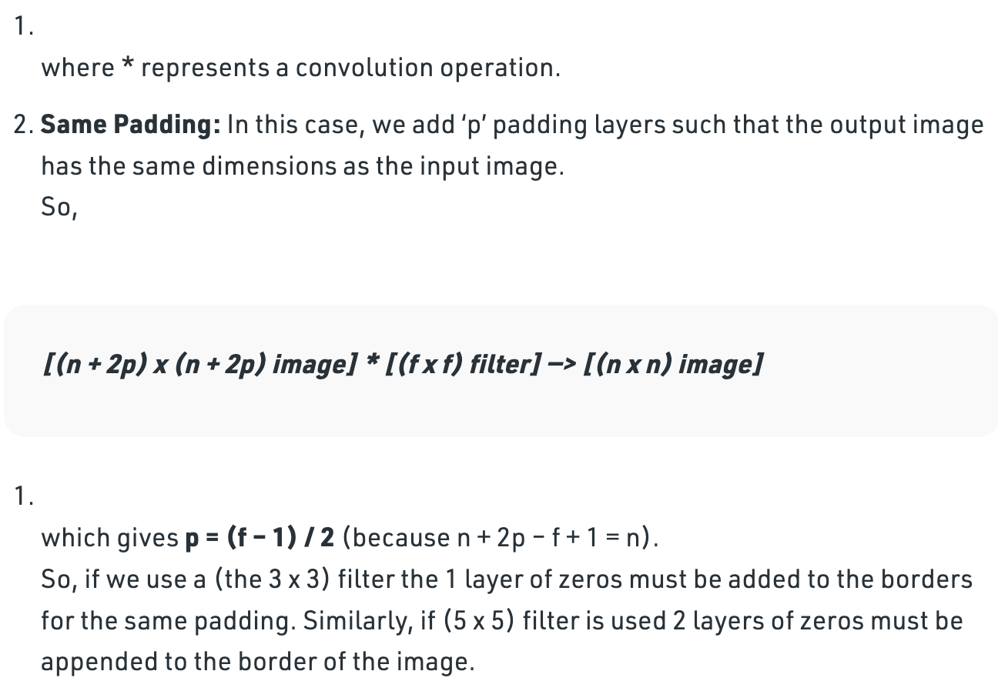

# **Strided Convolutions**

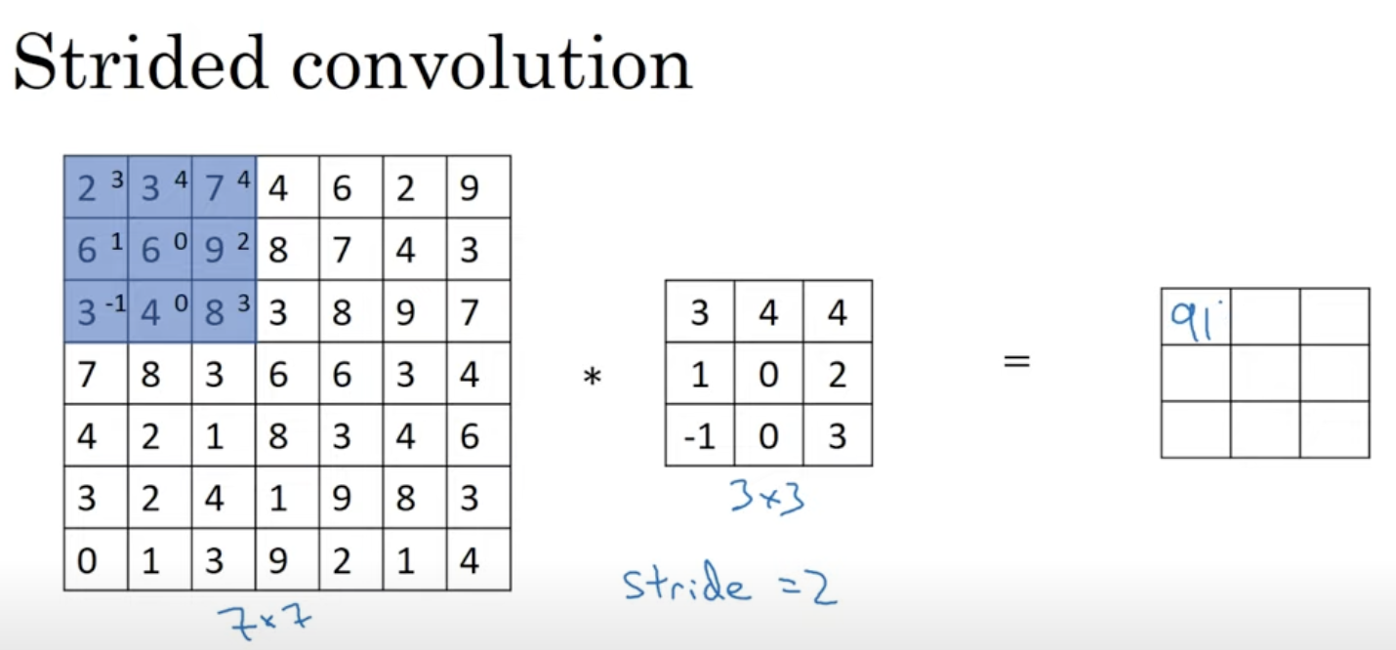

Instead of taking a single step, take 2 steps at a time.

Row-wise (2 steps)

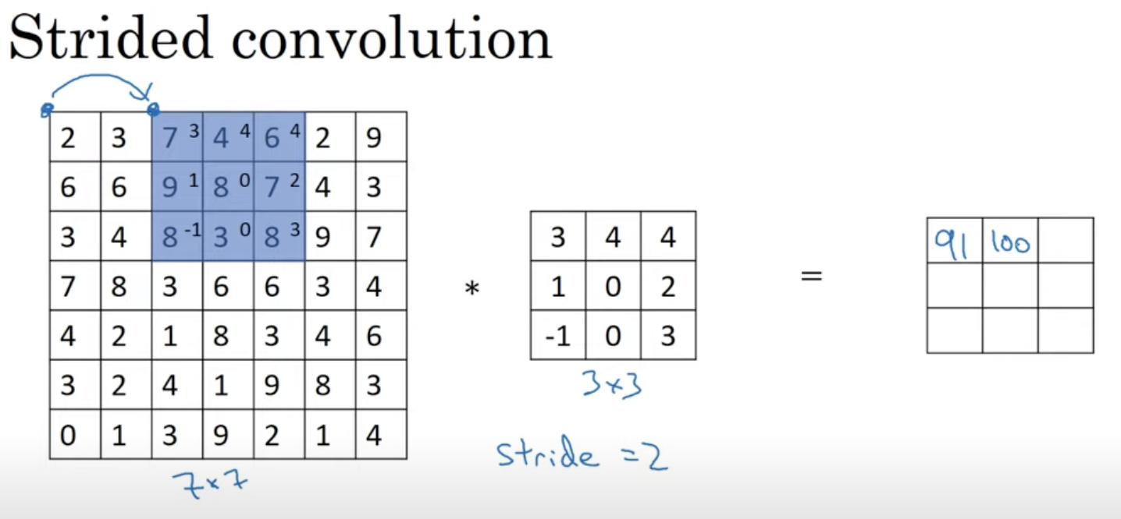

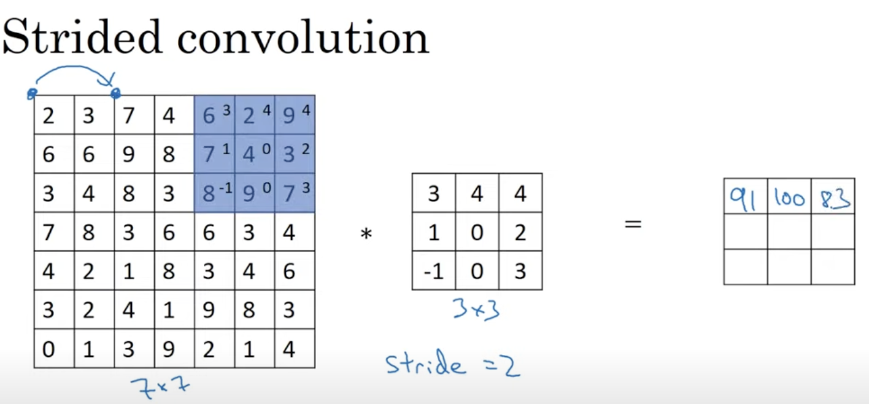

Column-wise (2 steps)

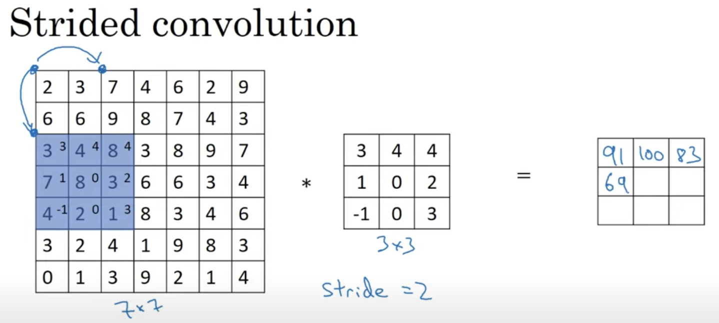

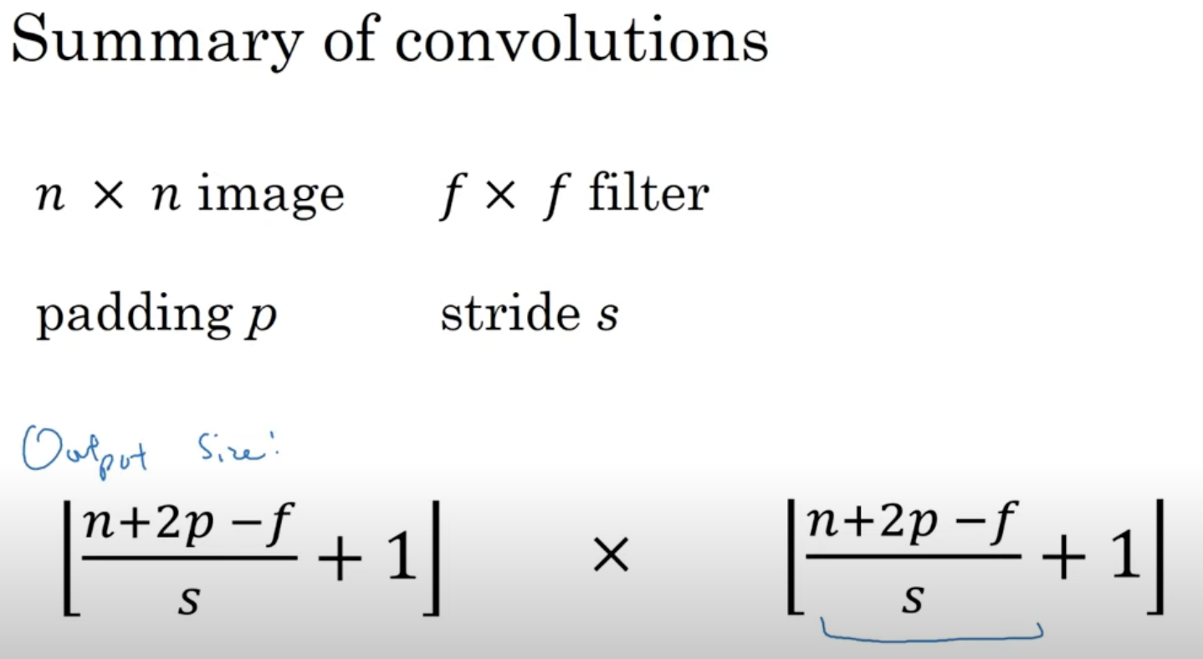

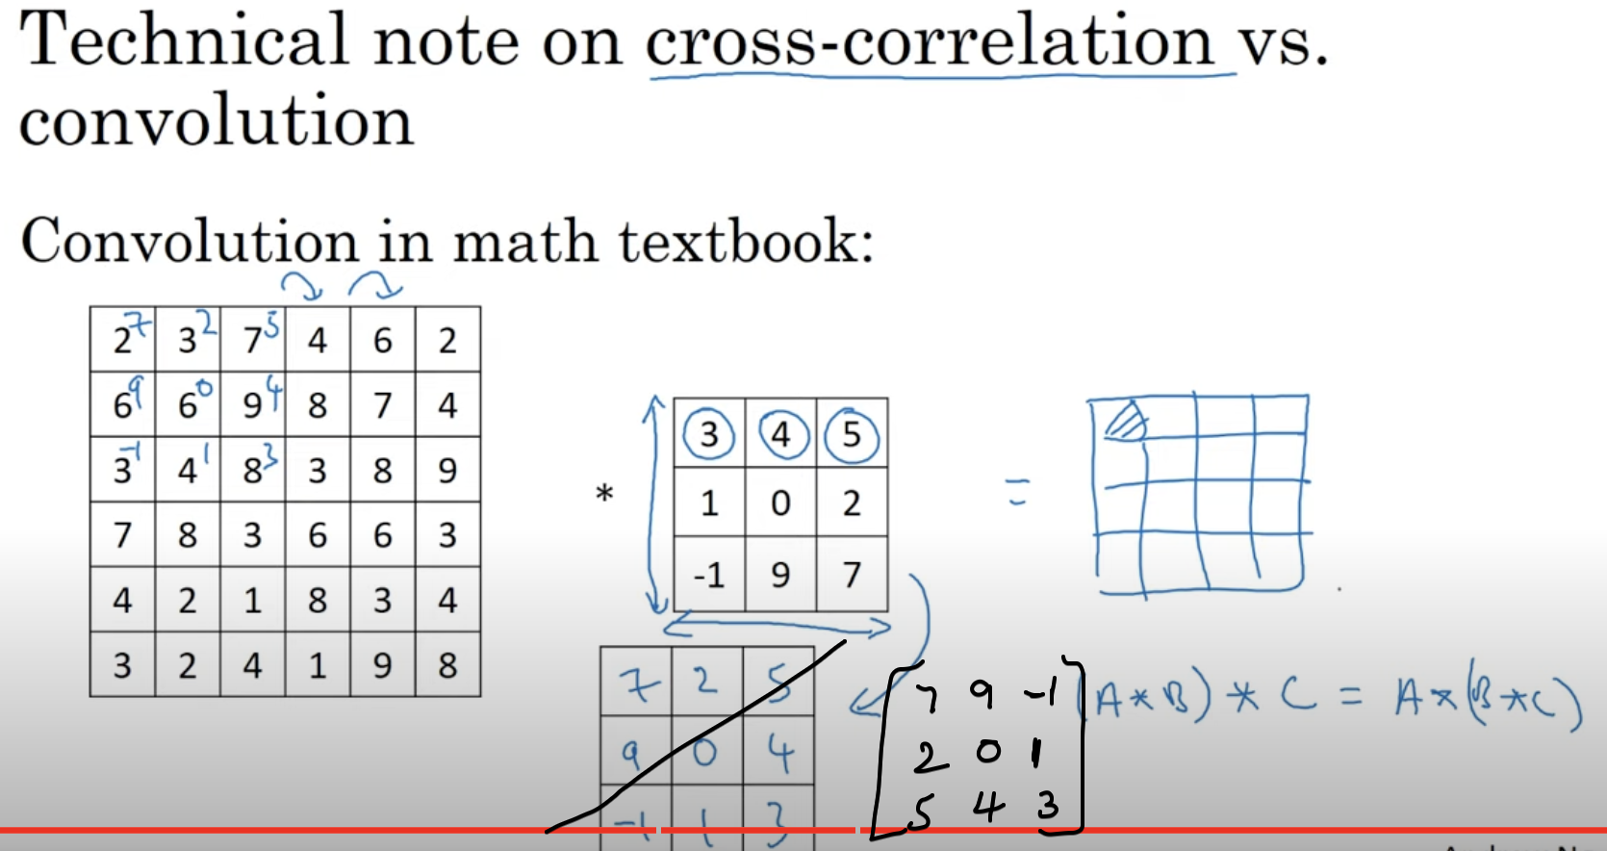

## **Rotating a matrix**

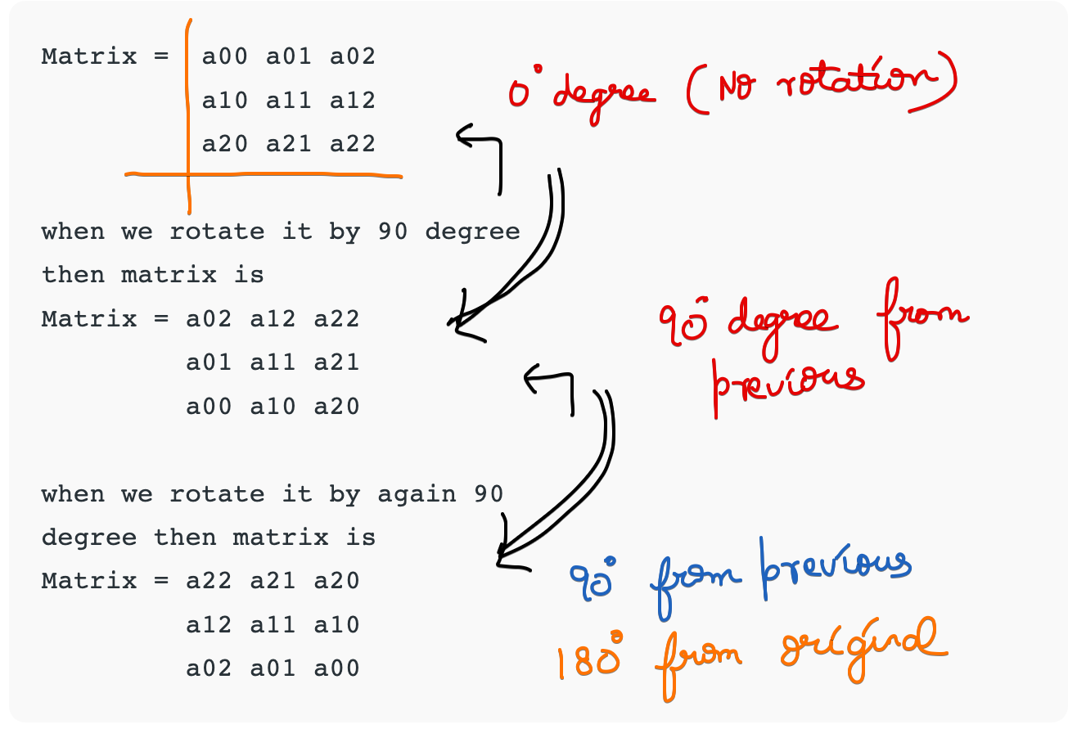

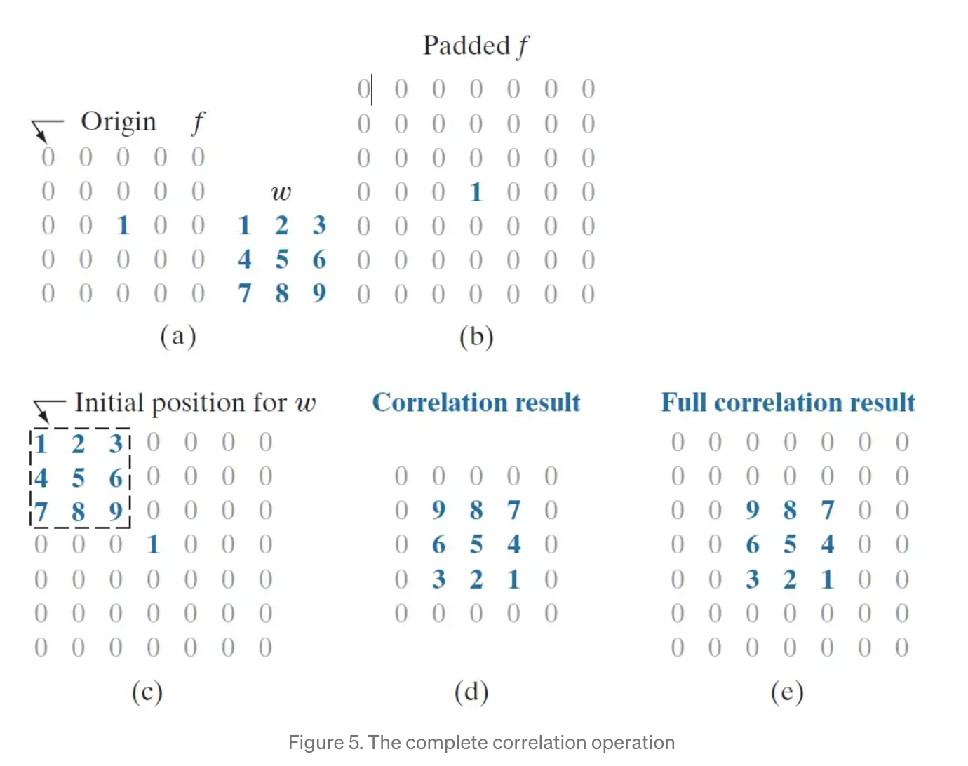

After rotating w into 180 degrees, our w is 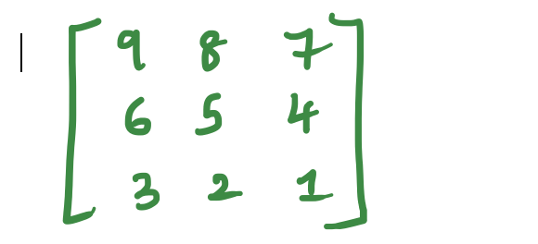

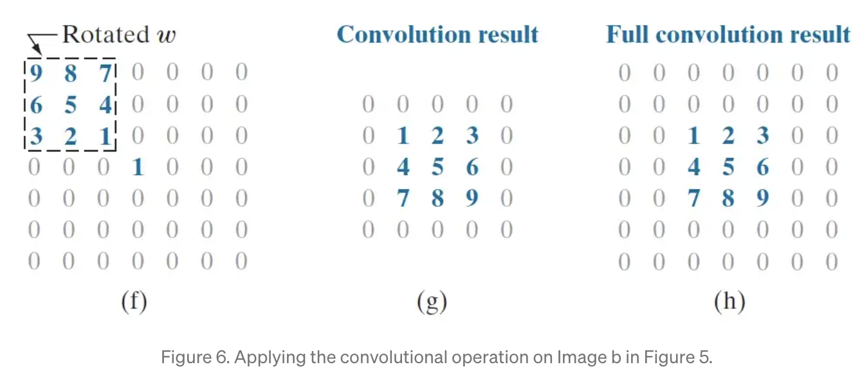

# **Convolutions over Volumes**

Till now we saw only convolutions only in Gray Scale image, Now we are going to explore the convolutions in RGB images.

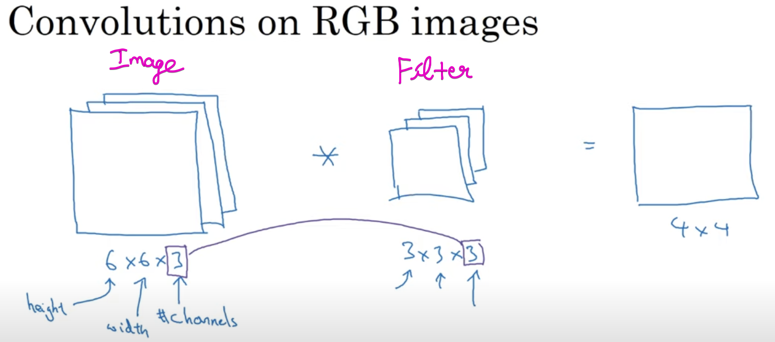

Number of Channels (Image) = Number of Channels(Filter)

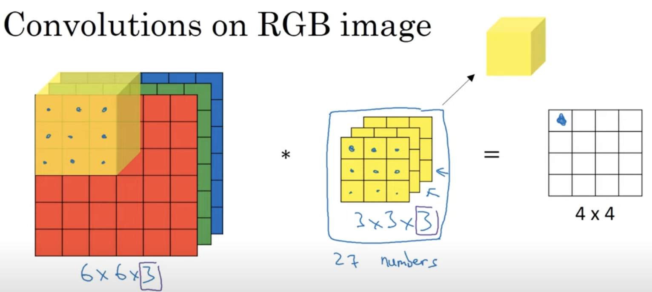

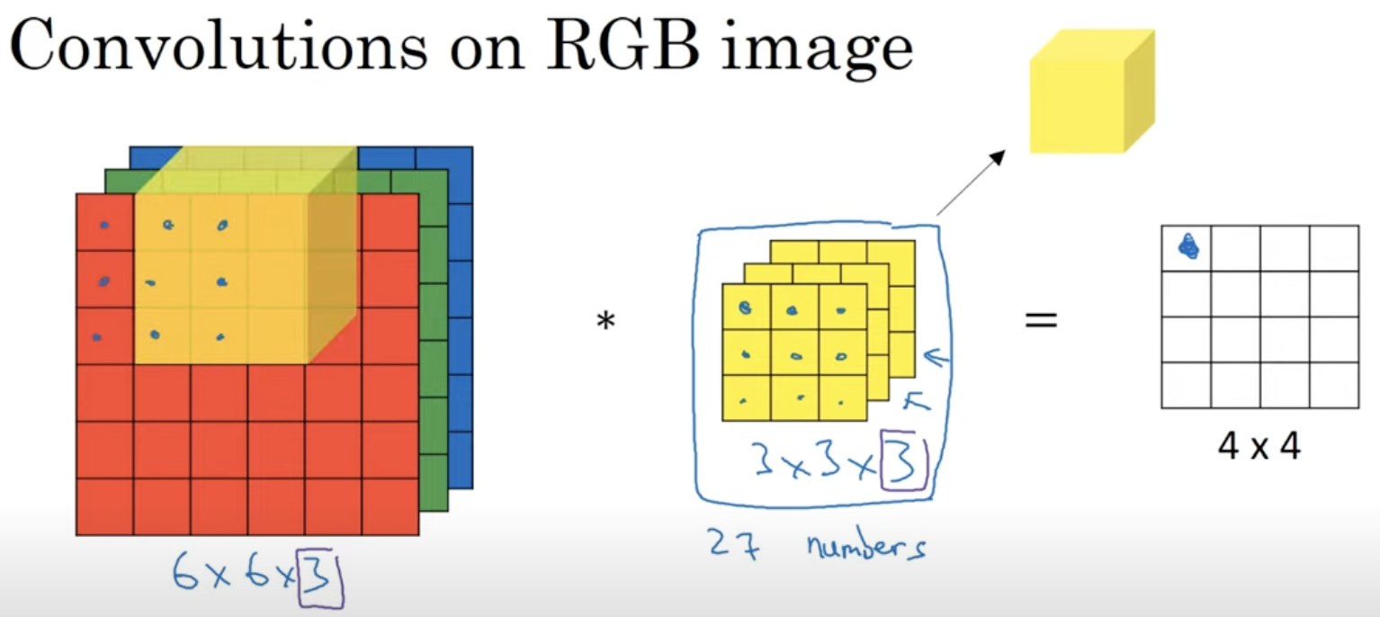

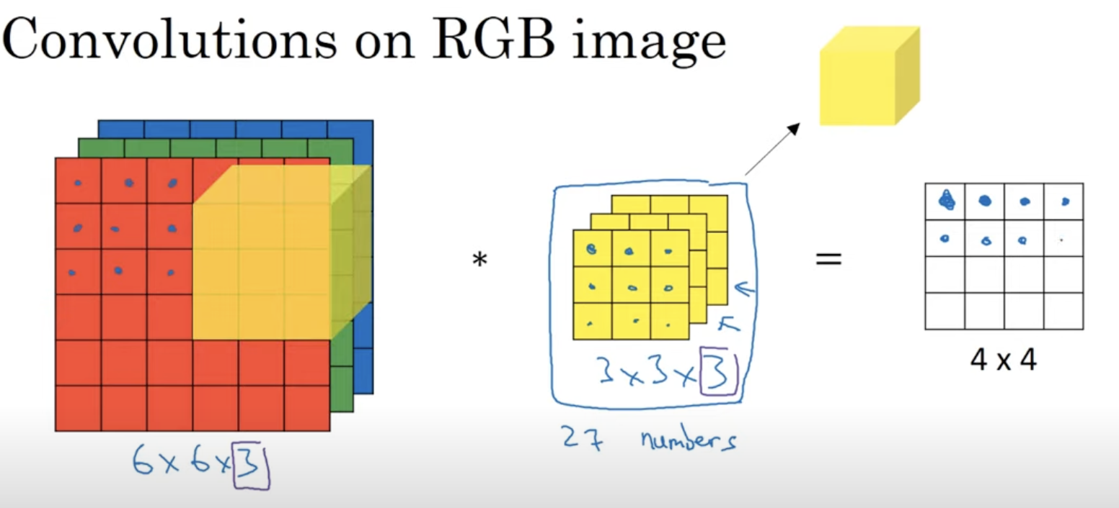

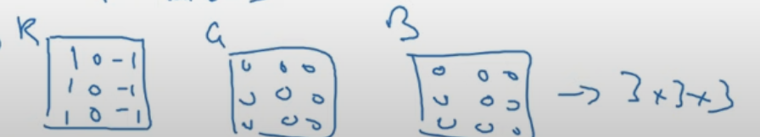

This will detect only the vertical edges only in the red channel.

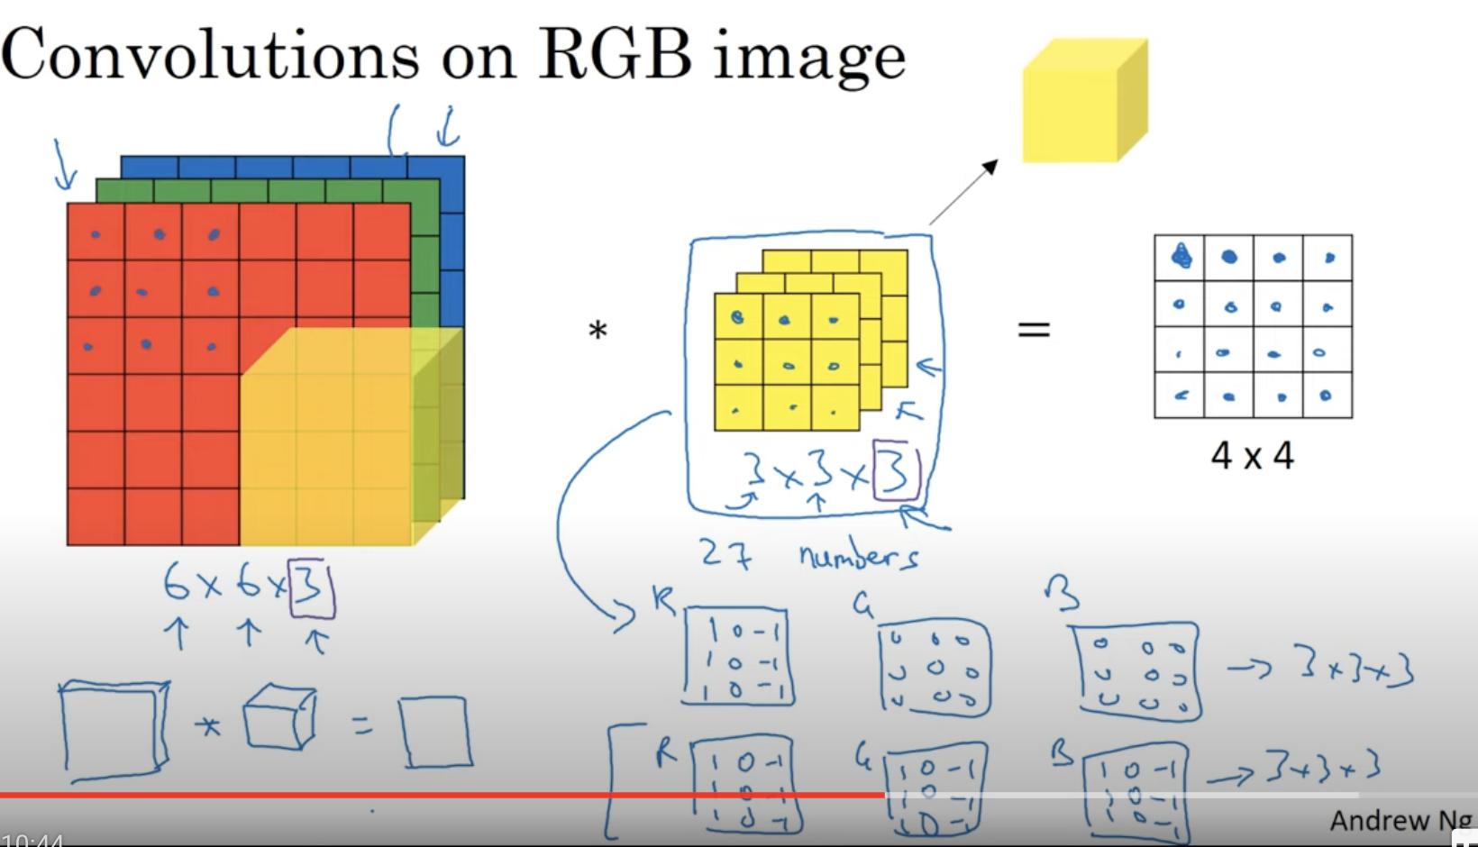

With different choices of these parameters, you can get different feature detectors

These filters will have a potential of different height, different width but the same number of channels.

Up-to now only vertical edges are covered, How horizontal edges are covered???  
Lets take both vertical and horizontal filter

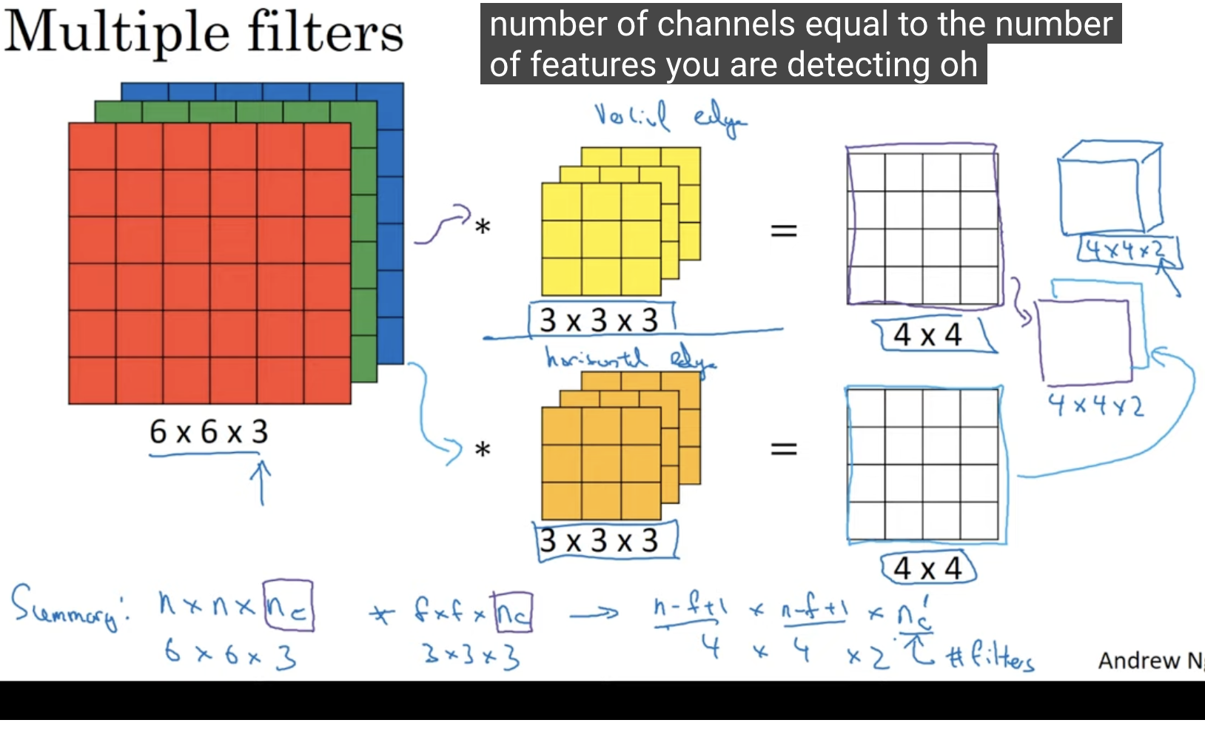

There is no padding done above, if padding there then the equation changes.

# **One Layer of a Convolution Net**

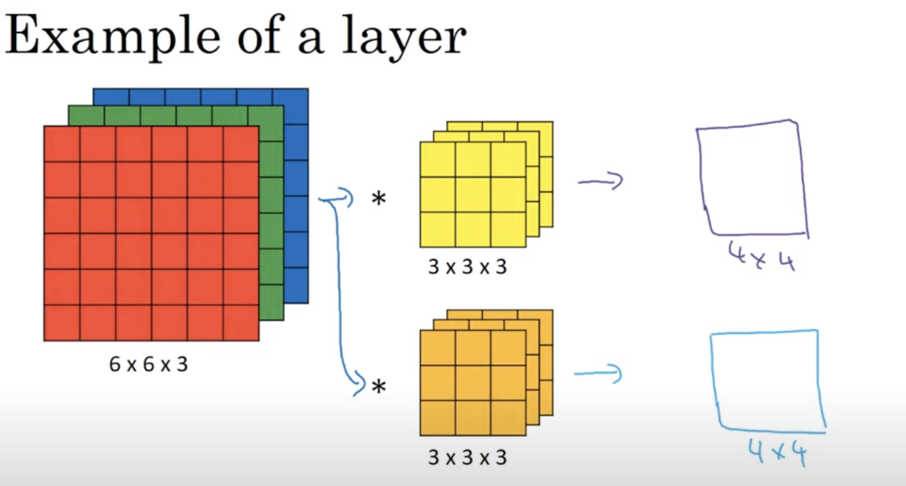

Convert the above into convolutional neural network layer

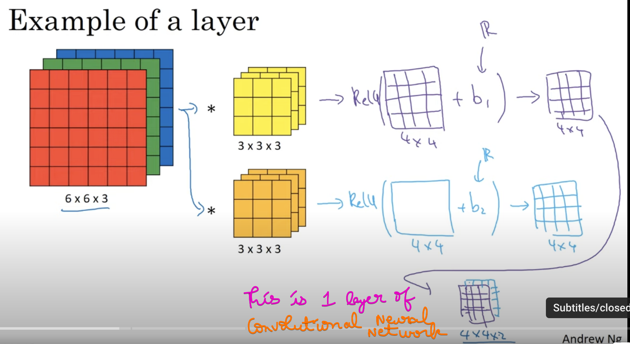

The above diagram is similar to a neural network of computing Z and a(Z)

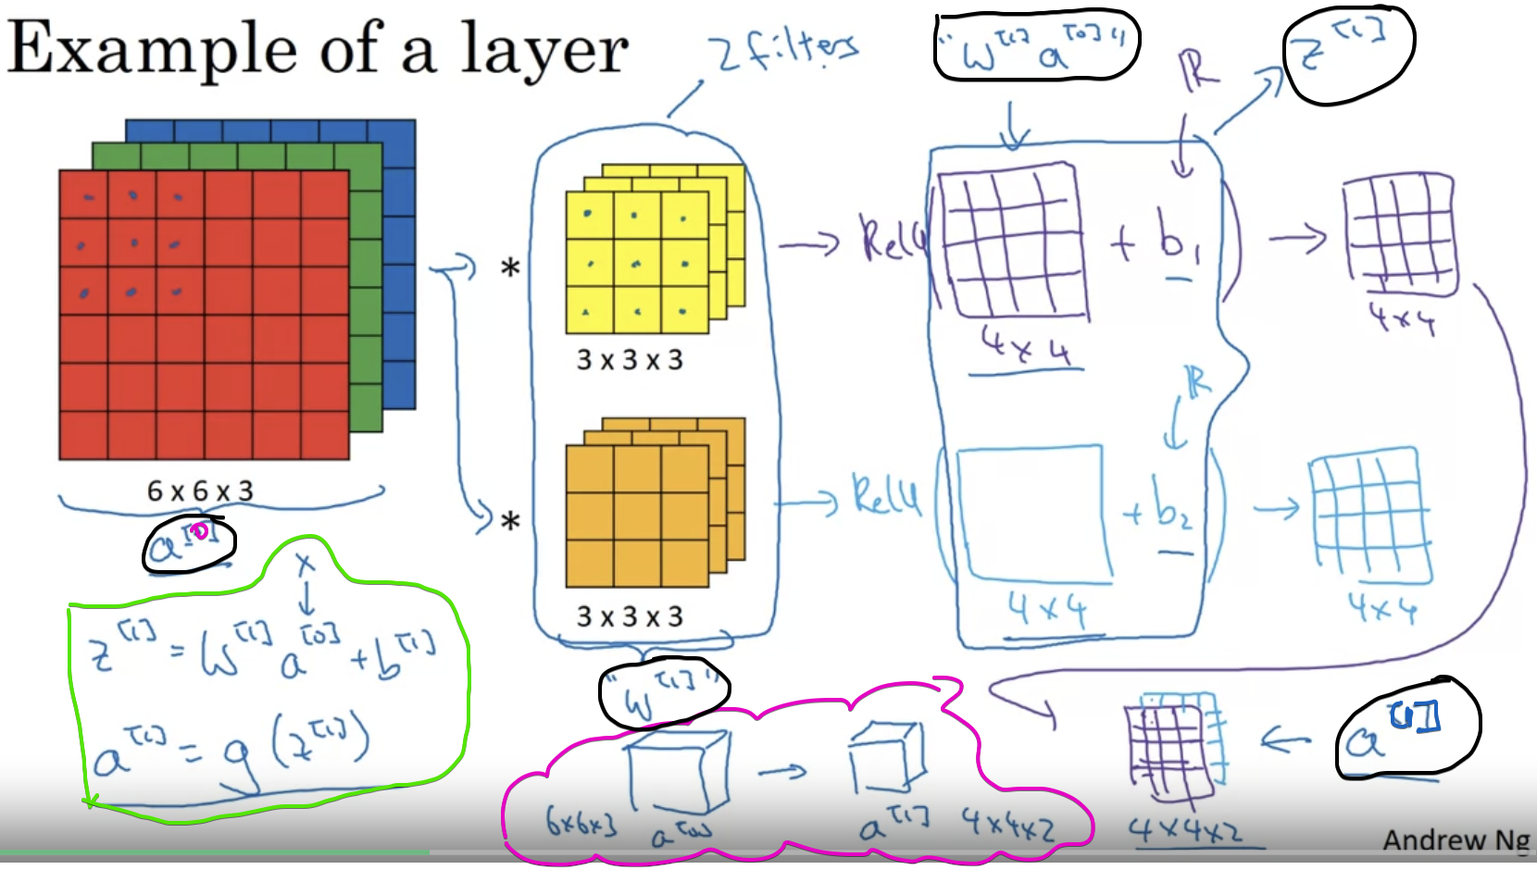

Here we are having 2 filters, so we obtain 4*4*2 as output  
Suppose if we have 10 filters, we would get 4*4*10 as output

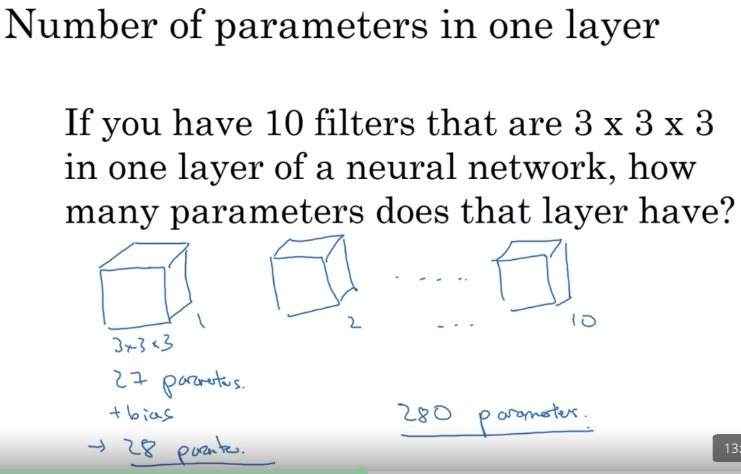

No matter how big the input image is, there are 280 parameters.  
Lets take an example, a set of images have been trained and obtained 280 parameters

These 280 parameters can be used to predict the vertical, horizontal edges of an other images also 🡪 Very Less Prone to Over-fitting

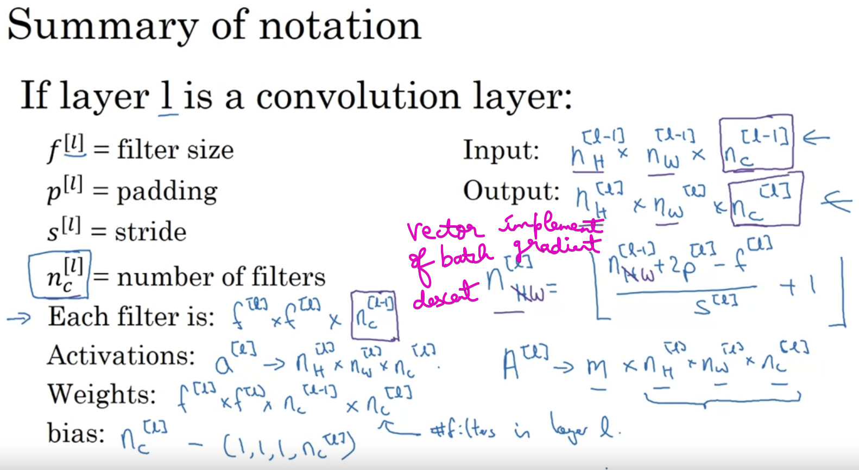

H->height and W->width  
Number of channels in the input image = Number of filters used =   
Number of channels in the output image

# **Simple Convolution Network**

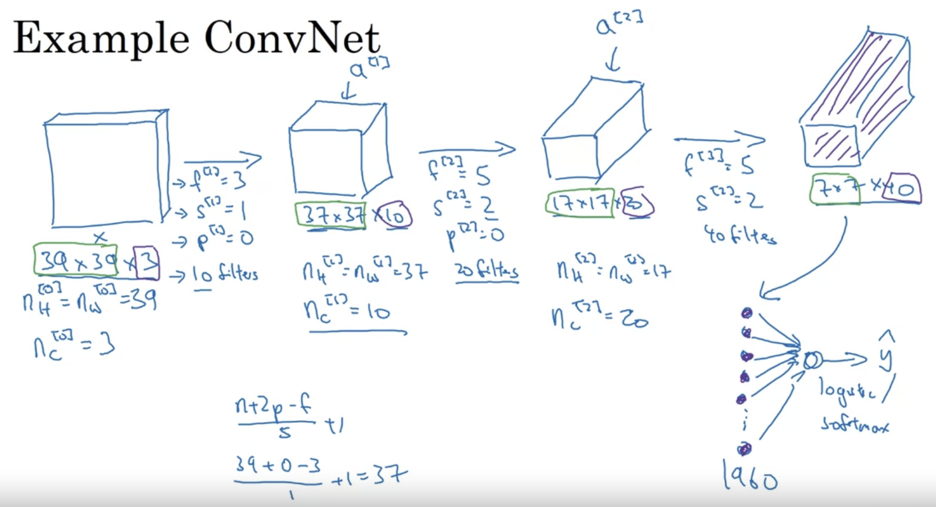

Taken 39*39*3 image, we have computed 7*7*40 feature for this image.

7*7*40 = 1960 (i.e 1960 long vector/units in a single layer)

Height*Width goes on decreasing 🡪 39*39 to 37*37 to 17*17 to 7*7

Number of channels goes on increasing 🡪 3 to 10 to 20 to 40

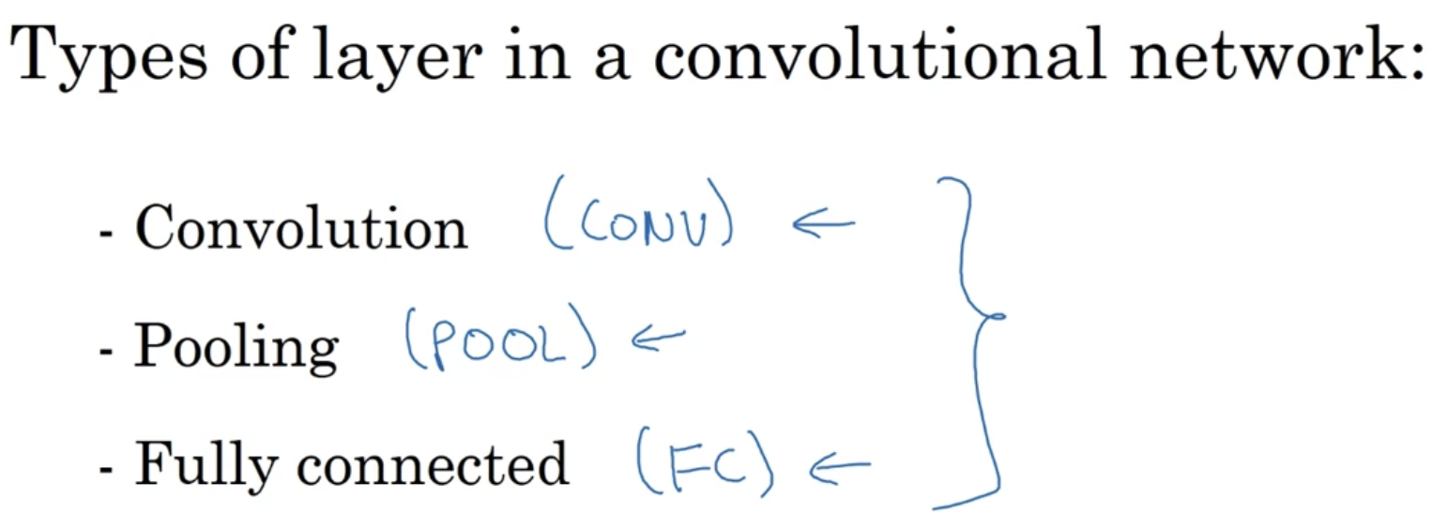

# **Pooling Layers**

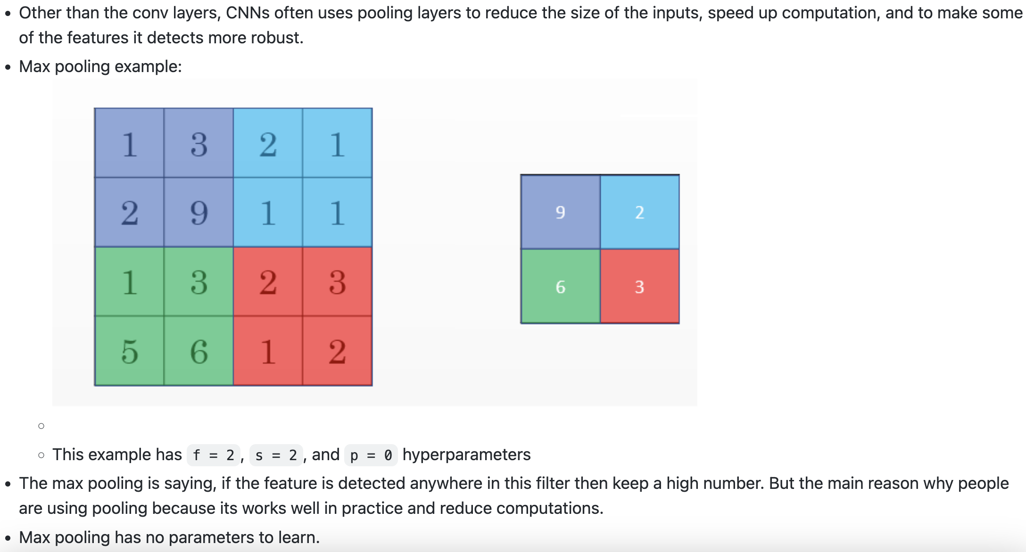  
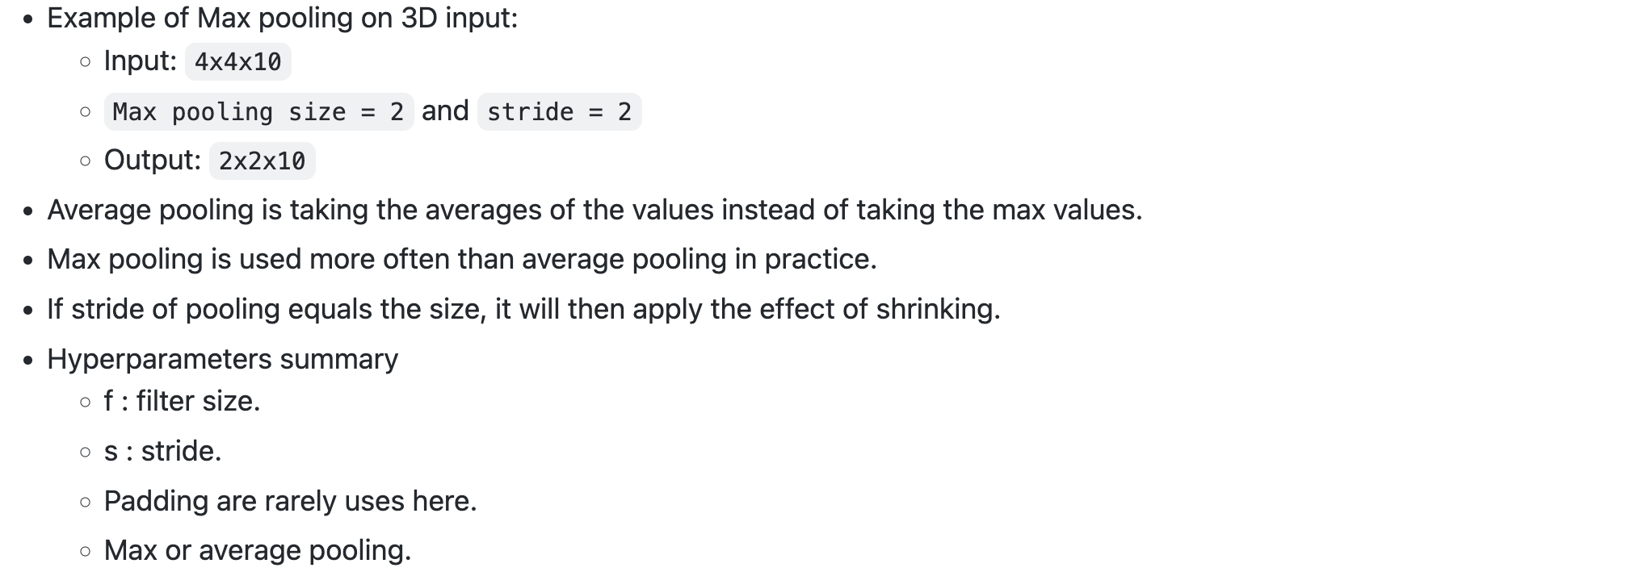

We took then filter size = 2 and Strided = 2

MaxPooling has a set of hyper parameters but it has no parameters to learn.   
There is actually nothing for gradient descent to learn.   
Once if you fix f and s, it is just a fixed computation and gradient descent doesn’t change anything.

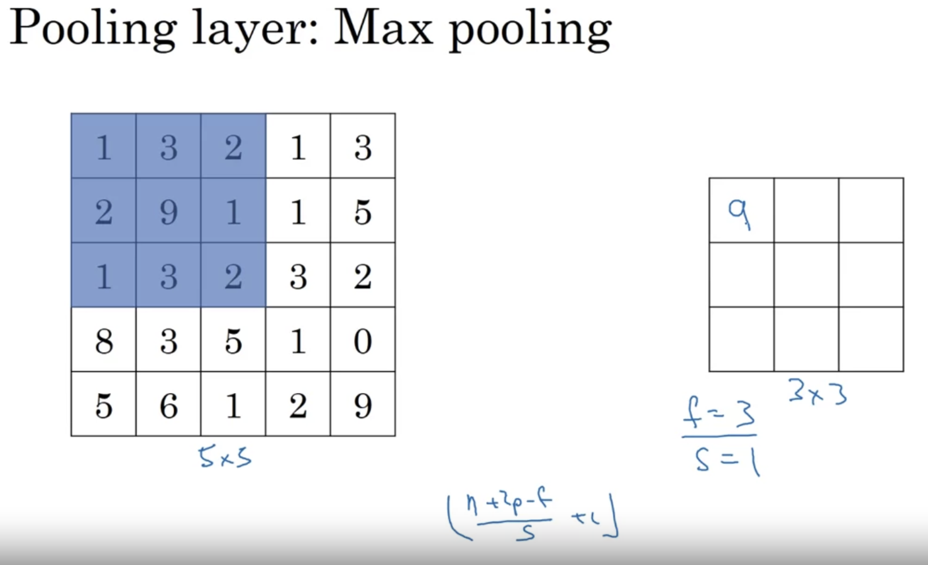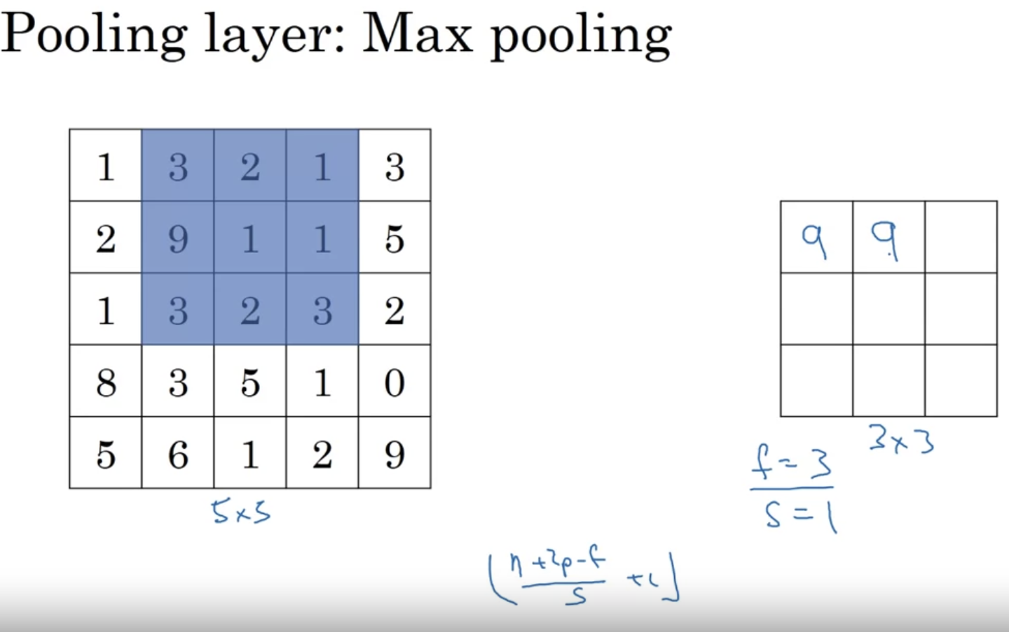

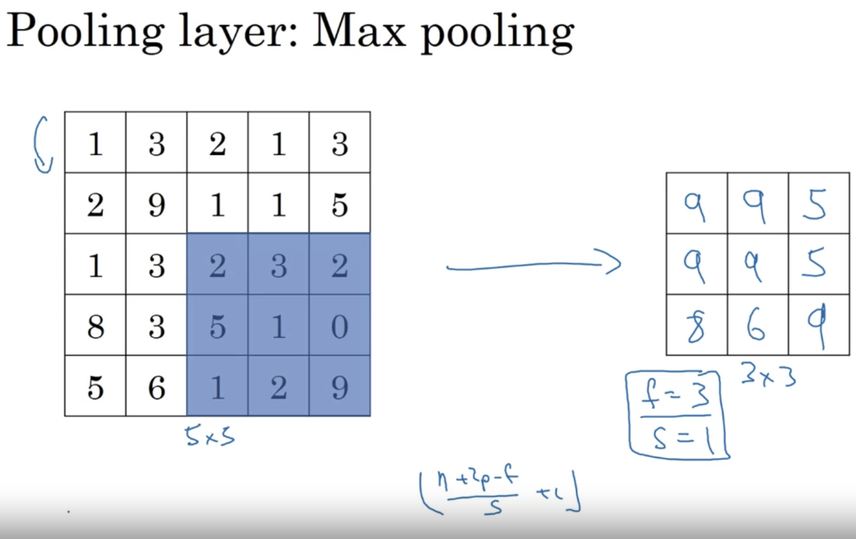

So far we have saw only 2D grey-scale, Lets apply to the 3D layer

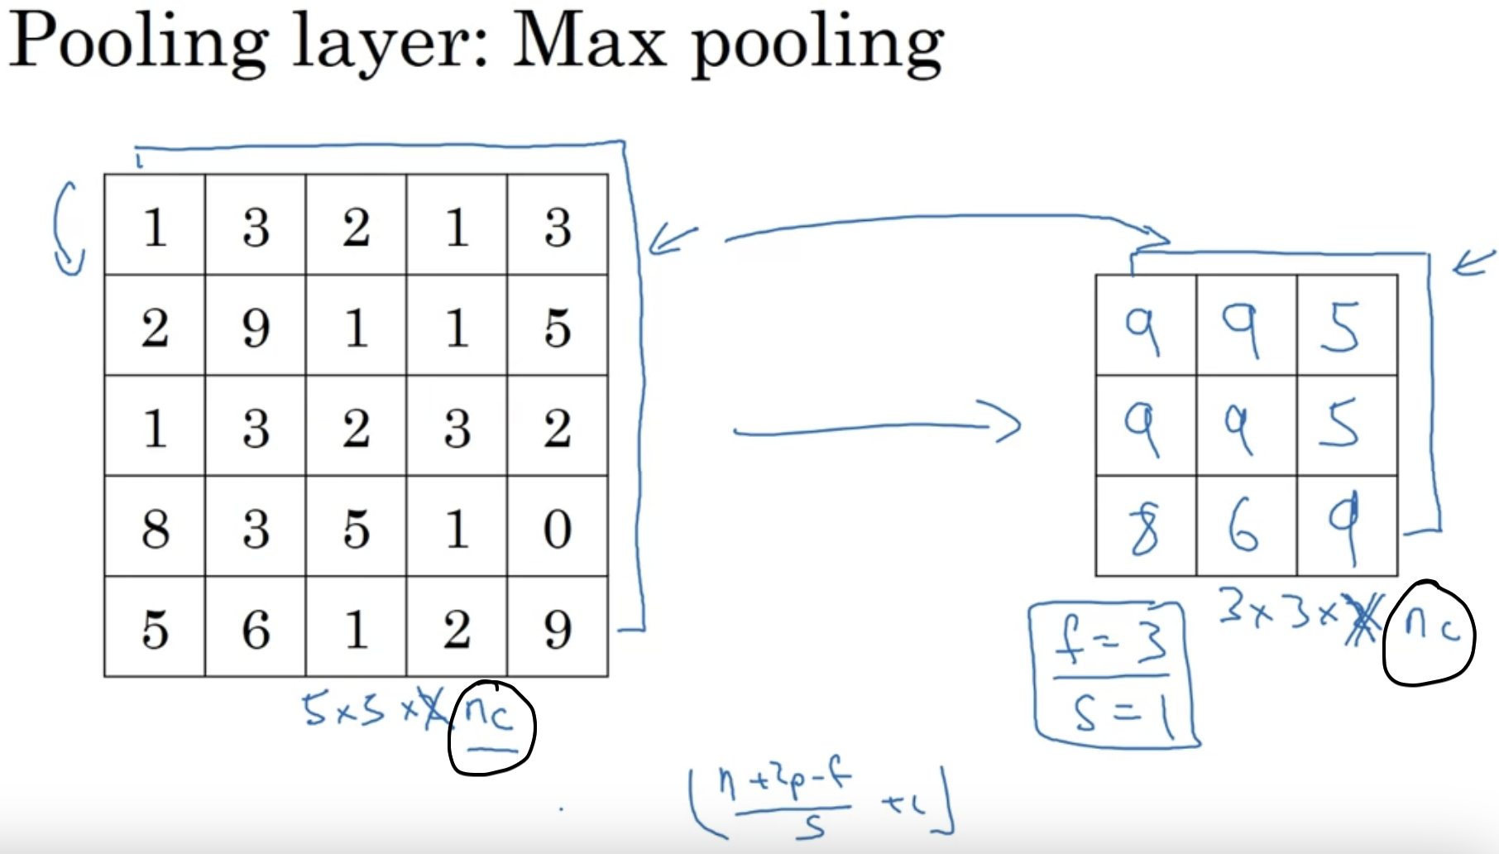

Input image 🡪 **5*5*nc** we also obtain the output image 🡪 **3*3*nc**Max Pooling is done independently on each of the separate channels

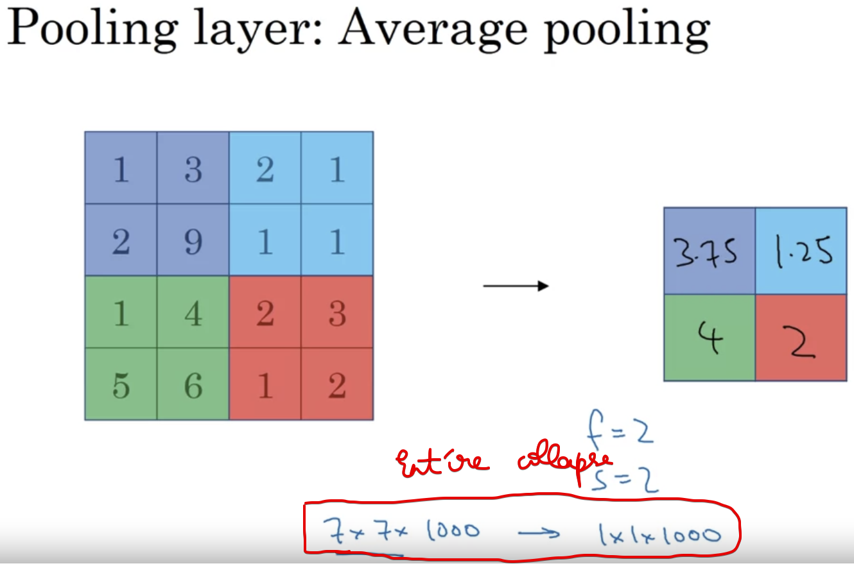

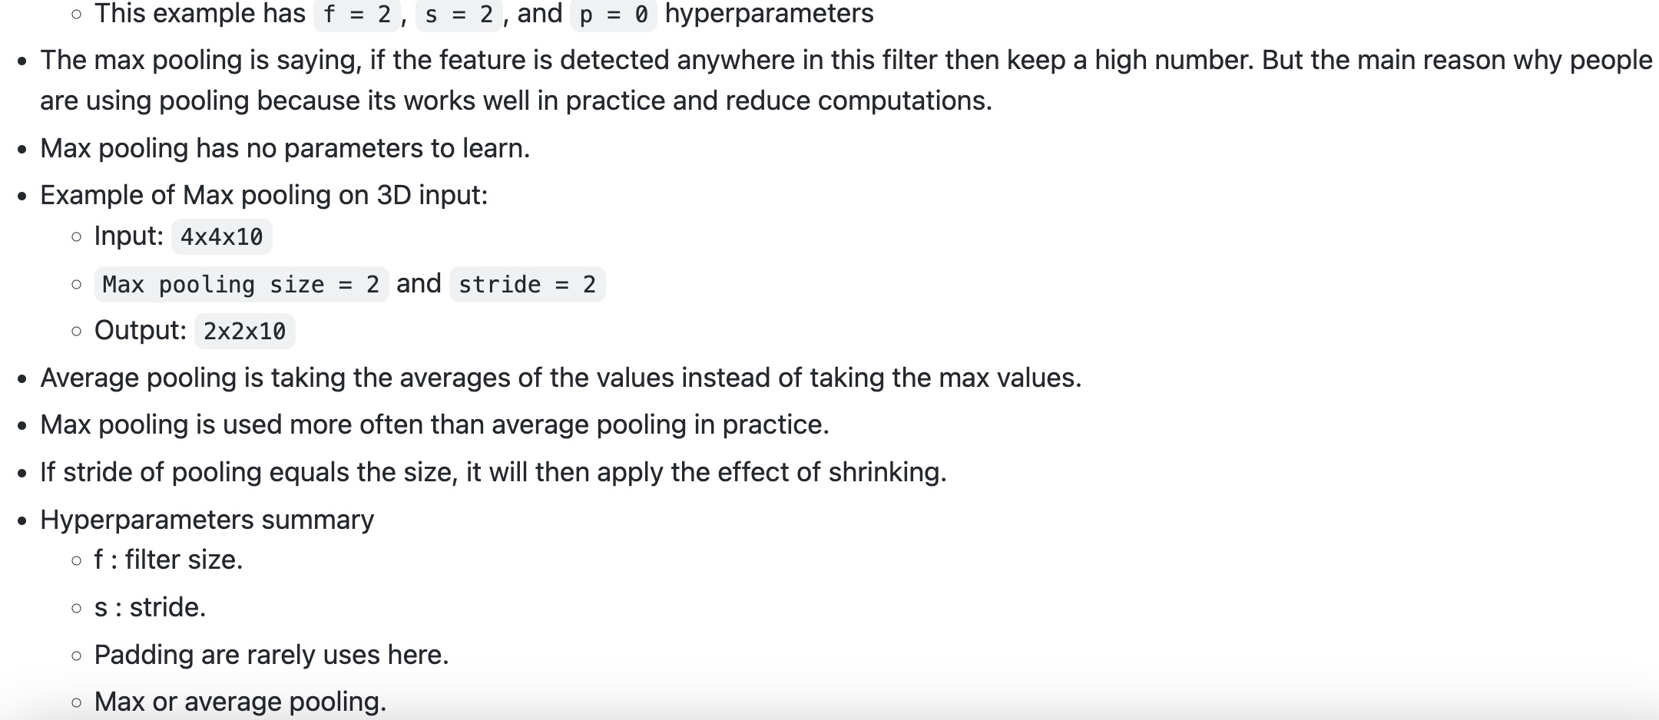  
So Max Pooling is preferred.

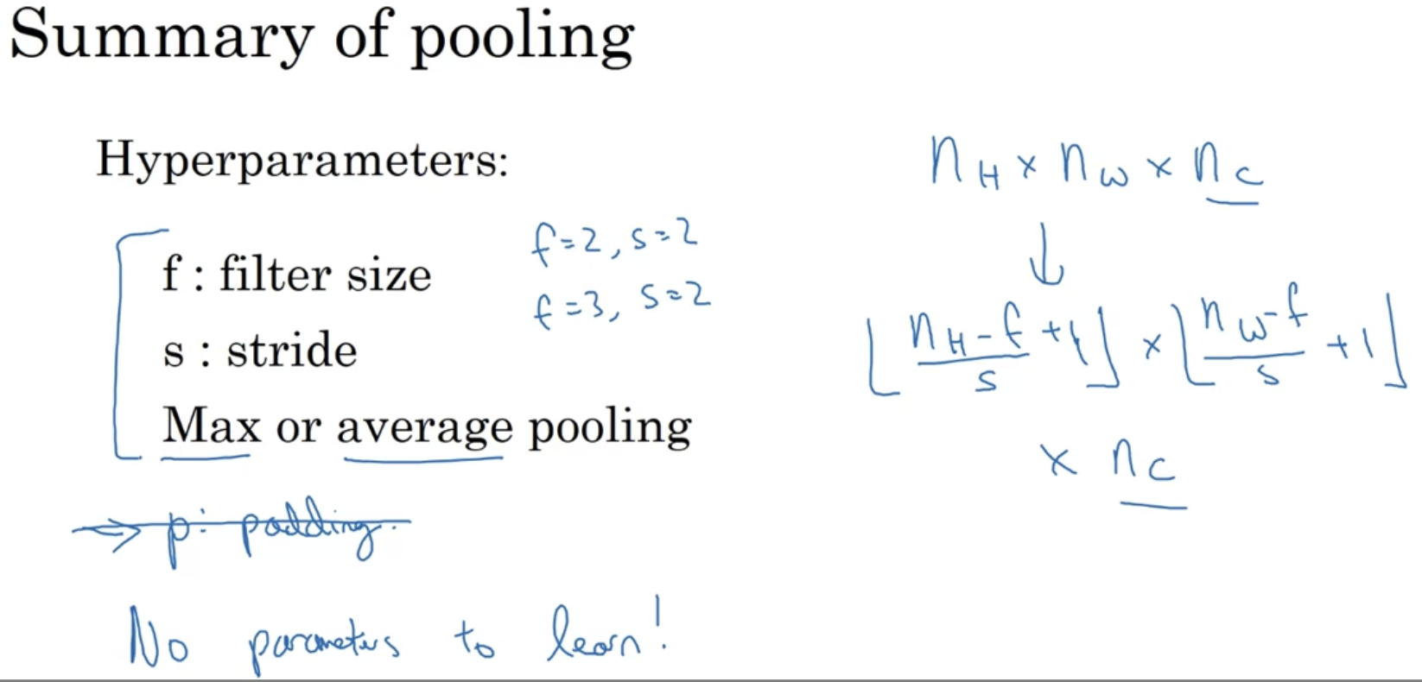

When we use Max Pooling, we won’t use any padding

# **CNN Examples**

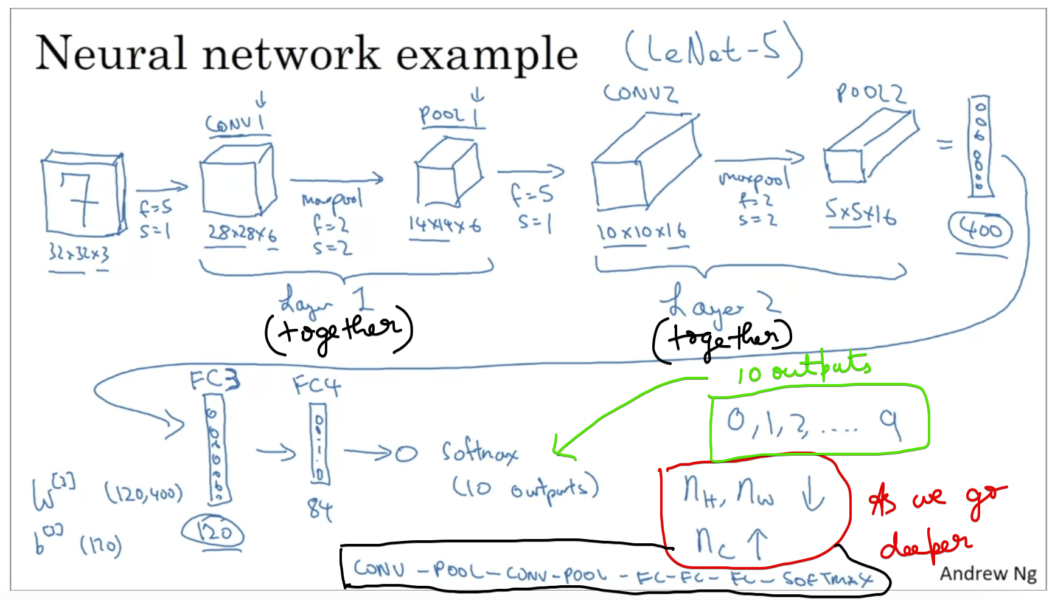

Each of the 400 units is connected to the 120 units and also the bias parameter

As we go deeper and deeper, the number of height&weight decreases and number of channels increase

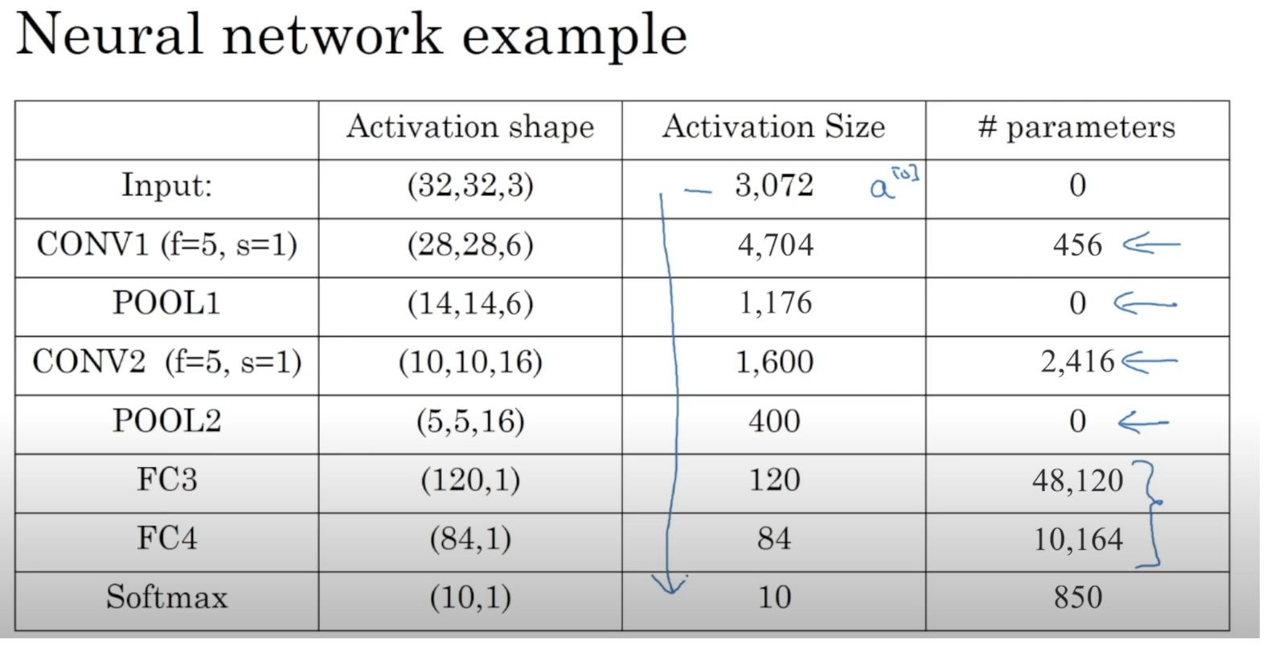

Activation size goes down gradually as we go deeper in the neural network

# **Why Convolutions ??**

# **Code Basics**

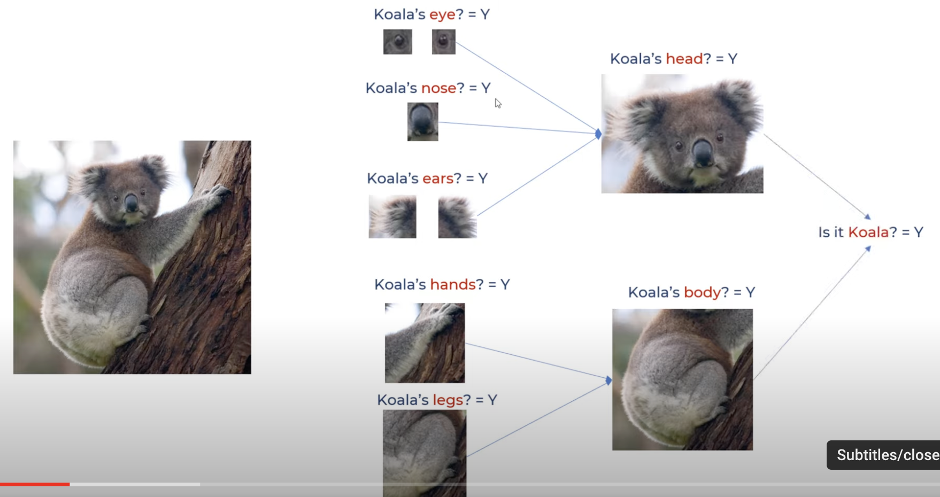

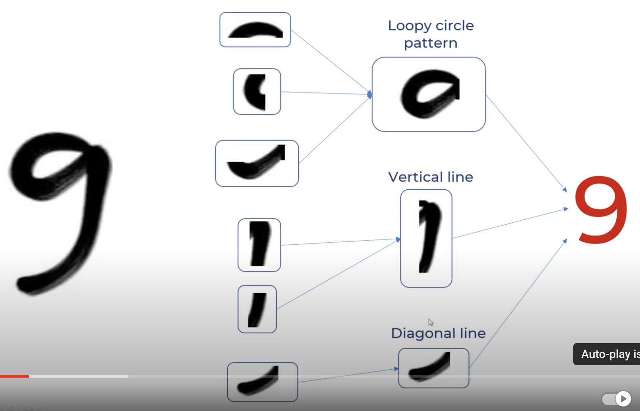

As normal humans, our brain splits these images and see then will come to the answer.

Similarly Computer also wants to see the image into horizontal and vertical splits

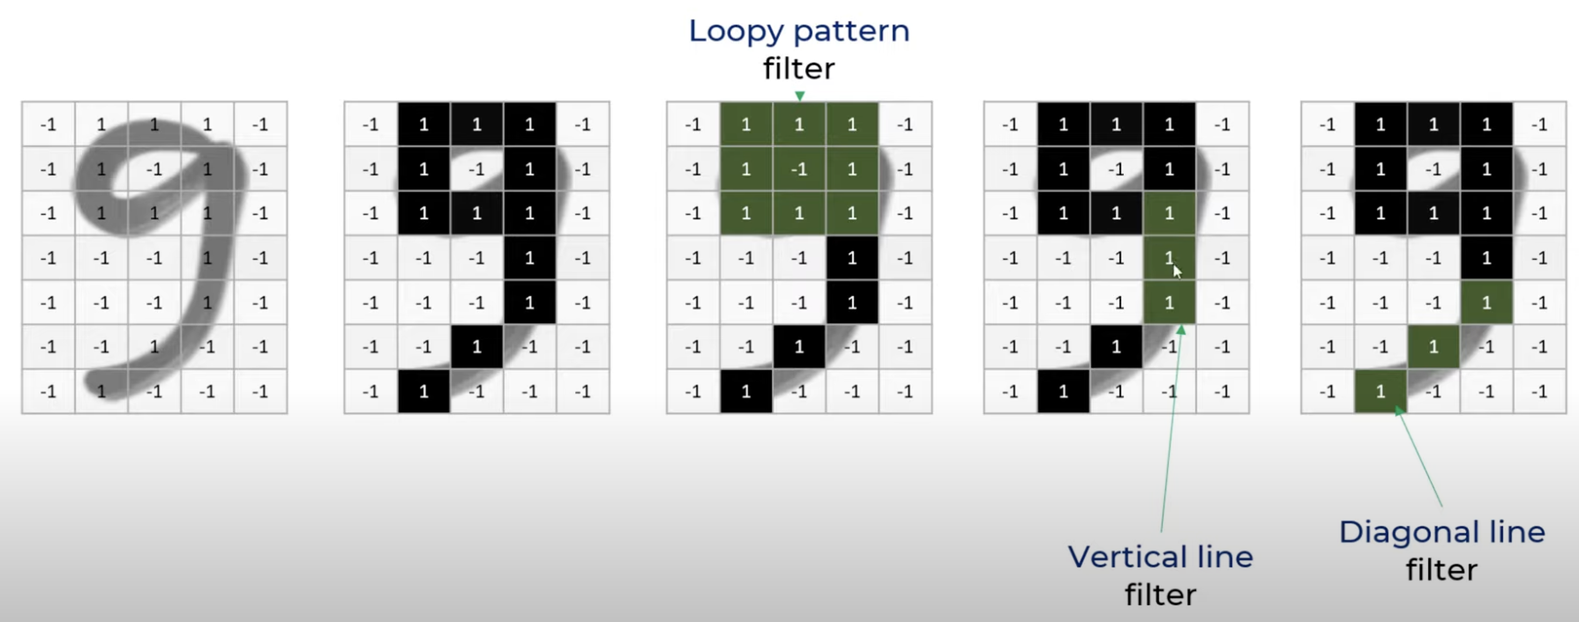

Filters are nothing but feature detectors

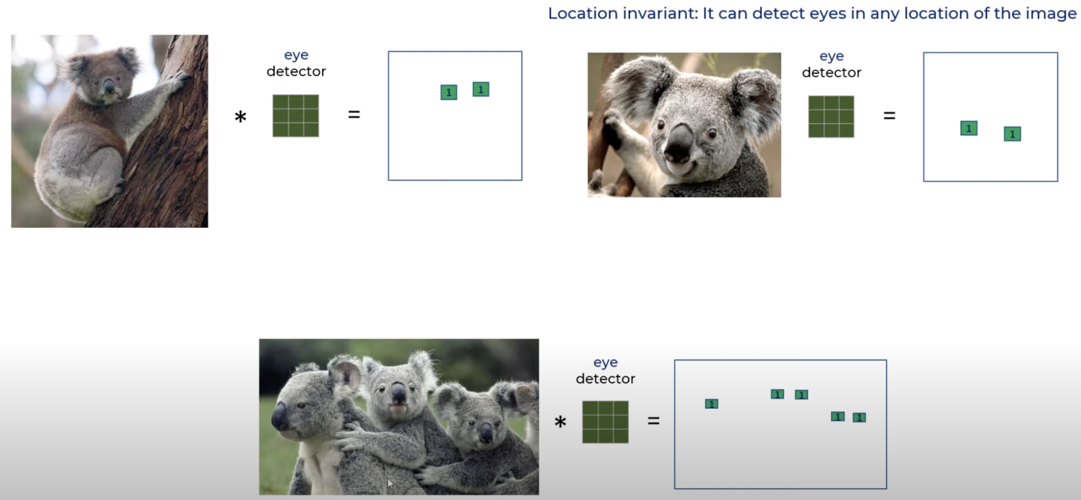

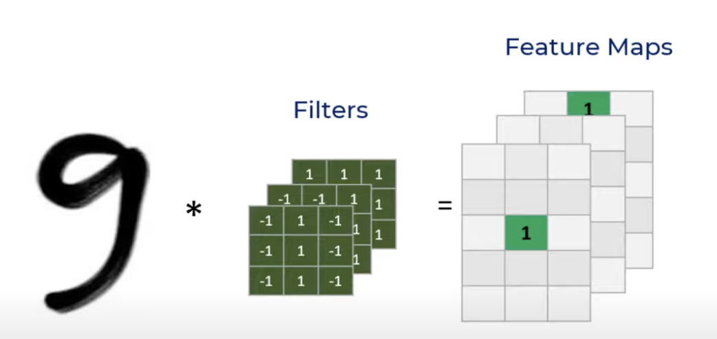

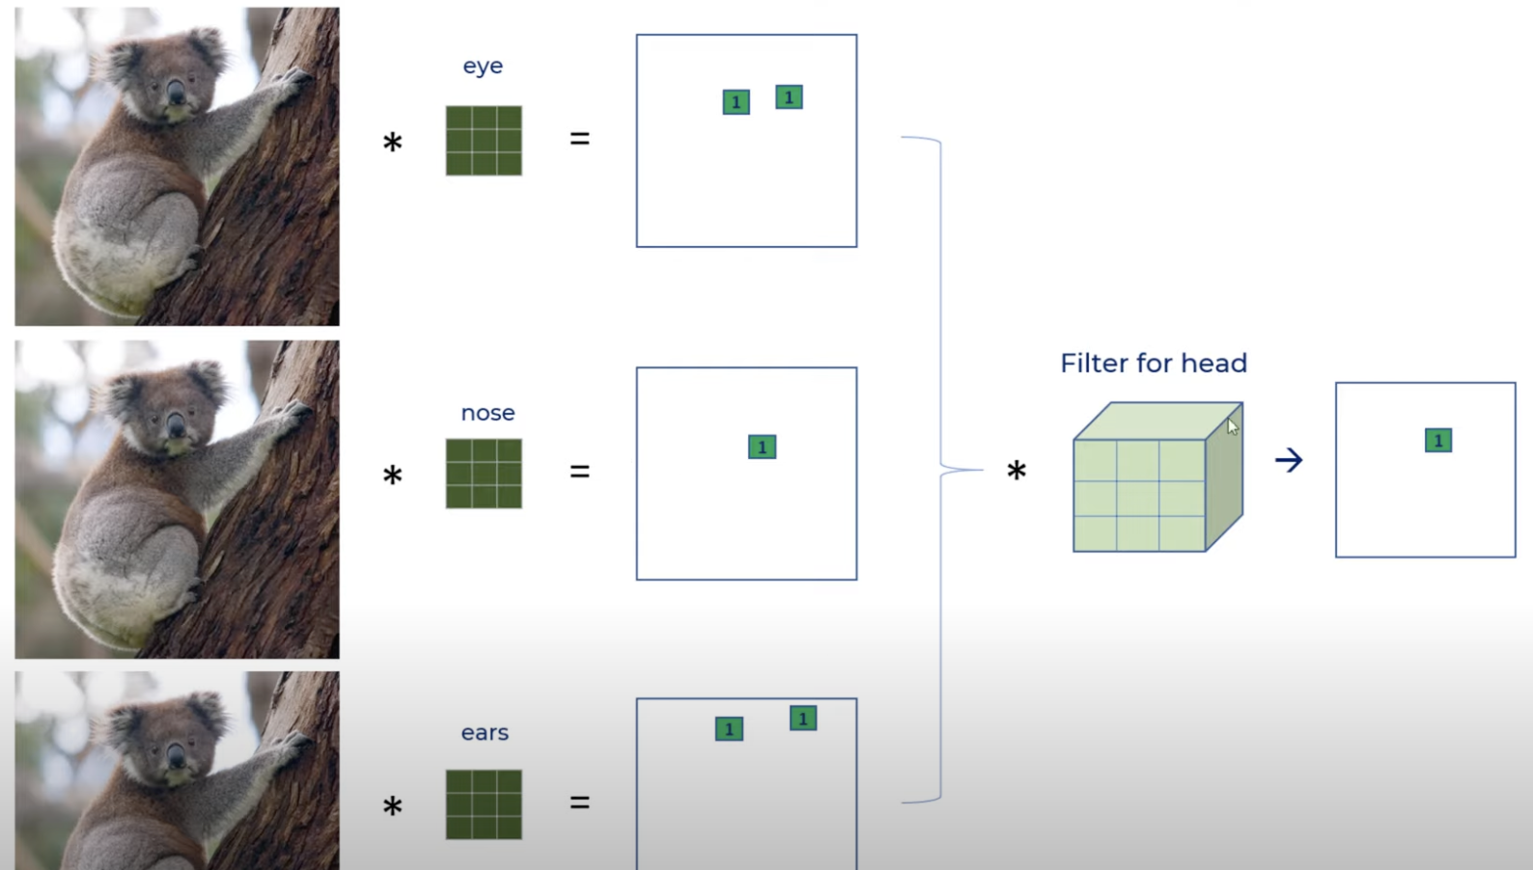

1st dimension -> eye and 2nd dimension -> nose and 3rd dimension -> ears

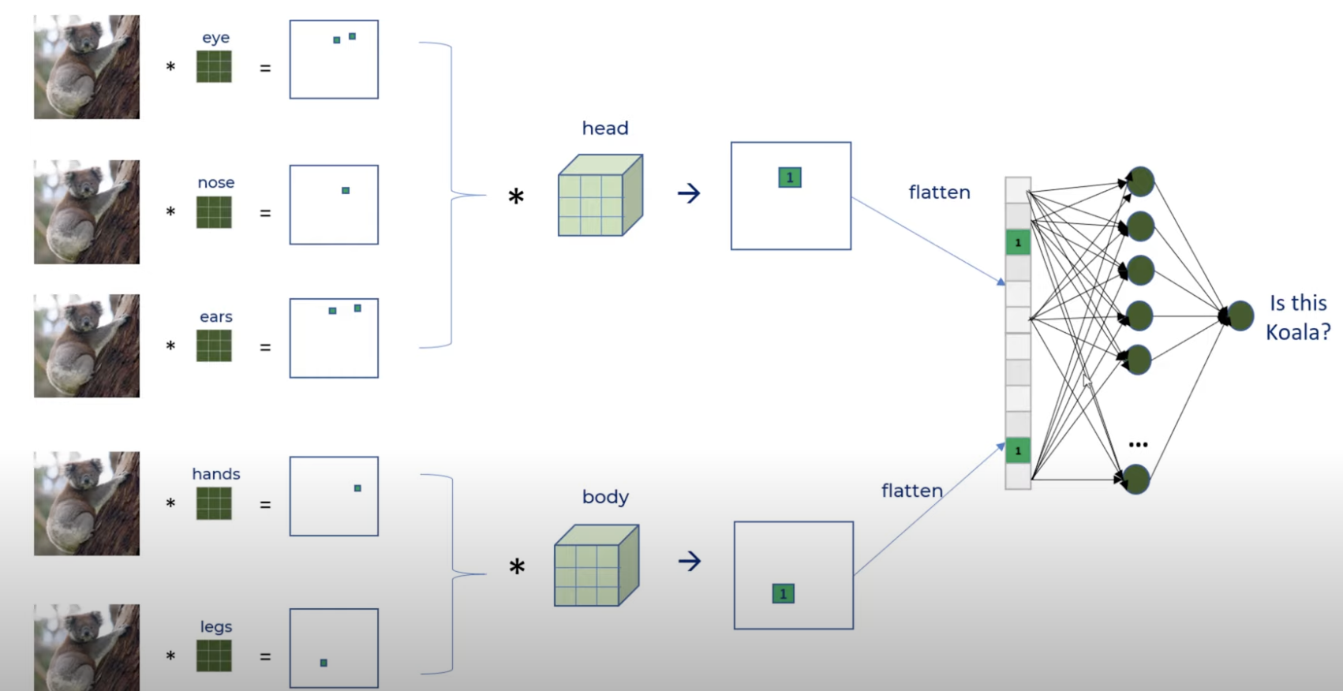

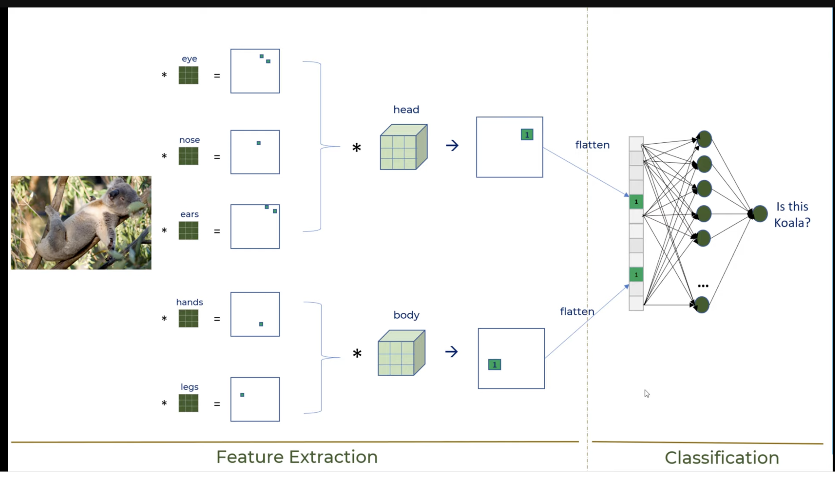

# **References**

<https://www.youtube.com/watch?v=-pmUQ6RSejQ>

<https://www.youtube.com/watch?v=GOygCUSKR5g>

<https://www.youtube.com/watch?v=zfiSAzpy9NM>